 | Autumn 1 | Autumn 2 | Spring 1 | Spring 2 | Summer 1 | Summer 2
History/Geography Focus | Geography Focus  The UK | History Focus  Stone Age and Iron Age | Geography Focus  Extreme Earth | History Focus  Riotous Royalty  Tudors/Kings and Queens | Geography Focus  Mediterranean | History Focus  Ancient Greece
English | FANTASY  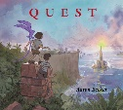  Quest  Author:  Aaron Becker | INSTRUCTIONS  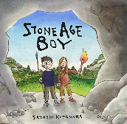  Stone Age Boy  Author:  Satoshi Kitamura  * | TRADITIONAL TALE  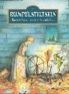  Rumpelstiltskin  Author:  The Brother Grimm | RECOUNT  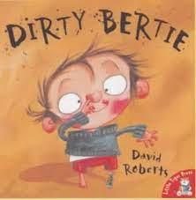  Dirty Bertie series  Author:  Alan McDonald | ADVENTURE  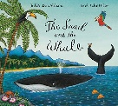  The Snail and the Whale  Famous Author:  Julia Donaldson  * | INFORMATION –  Non-Chronological report  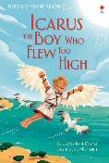  Icarus the boy who flew too high  Author:  Katie Davies  *
Art | Painting/sketching  -Local field sketch  Colour backwash, reflection, UK  Artist:  Monet  * | Painting/Sculpture  -Cave Paintings  * |  | Drawing  -Portraits  (Henry VIII)  Artist:  Hans Holbein the younger  (Leonardo da Vinci)  * | Painting  -Sea paintings  Artist:  Shelley Cunningham | Drawing  -Greek geometric patterns  Sculpture  -Greek architecture (columns)  *
Design and Technology |  | Structures  Clay Roundhouse  Make tools | Structures  Create an erupting volcano  * | Structures  -Design and build a draw bridge to open and light up  * |  | Food Technology  -Greek day in school  *
Music  Charanga | Unit 1  Let Your Spirit Fly | Unit 3  Three Little Birds | Unit 4  The Dragon Song | William Byrd  Henry Purcell | Unit 5  Bringing us together | Unit 6  Reflect, Rewind and Replay
Science (Discrete) | Physics  Forces | Physics  Light | Chemistry  Rocks | Chemistry  Materials | Biology  Animals including Humans | Biology  Plants
PE | Outdoor and Adventurous | Gym | Dance | Competitive Games | Competitive Games | Athletics
RE | What are the rules?  -British Law  * | What do people believe about God? |  | That’s not fair! Or is it?’  -The last supper  * | What is so special about places?  -Religious places around Europe/ Mediterranean  *
ICT | E-safety:  Google Share with Care | Digital Literacy & E-safety:  Using a computer/ device | Digital Literacy: Explore a topic with research and collaboration | Coding:  Animations | Coding:  Sound and music | Coding:  Project
MFL  (French) | Listening, Reading, Speaking and Writing | Listening, Reading, Speaking and Writing | Listening, Reading, Speaking and Writing | Listening, Reading, Speaking and Writing | Listening, Reading, Speaking and Writing | Listening, Reading, Speaking and Writing
PSHE | Drug, alcohol and tobacco education: Tobacco is a drug | Keeping safe and managing risk: Bullying – see it, say it, stop it | Mental health and emotional wellbeing: Strengths and challenges | Identity, society and equality: Celebrating difference | Careers, financial capability and economic wellbeing: Saving, spending and budgeting | Physical health and wellbeing:  What helps me choose?

