 | Autumn 1 | Autumn 2 | Spring 1 | Spring 2 | Summer 1 | Summer 2
History/Geography Focus | Geography Focus  Rainforest  * | History Focus  Anglo Saxons  * | Geography Focus  Exploring Eastern Europe  * | History Focus  Local Study – link Stone Age, Iron Age, Romans and Anglo Saxons  * | Geography Focus  Changes in our loal environment  * | History Focus  Vikings  *
English | Fantasy  Leon and the Place Between  Author: Angela Mcallister  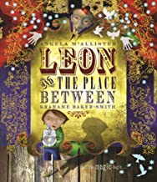 | Persuasion-  The Explorer  Author: Katherine Rundell  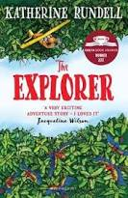  * | Traditional Tale-  The Pied Piper  Authors: Michael Morpurgo  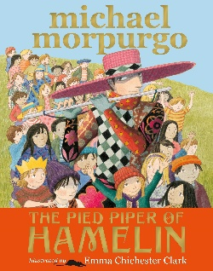  * | Chronological/  Diary Entry-  A Bear Called Paddington  Author: Michael Bond  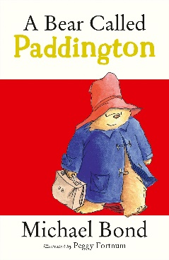 | Flashback  Freedom for Bron: The Boy Who Saved a Kingdom  Author: N.S. Blackman  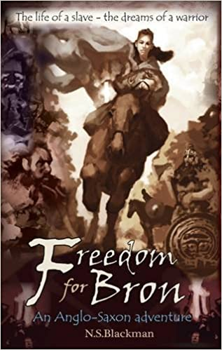 | Non-Chronological Report-  Malamander (The Legends of Eerie on Sea)  Author: Thomas Taylor  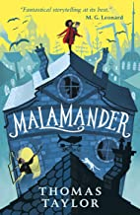  *  *
Art | Collage  John Dyer’s rainforests  * | Sculpture  Anglo Saxon pottery  * | Painting  Bob Ross’ landscapes  * | Printing  William Morris printing | Digital media  Portraits
Design and Technology |  | Textiles  Make an ancient hessian bag  * |  | Structure  Model past building of Loftus that includes electrical components  * | Cooking / nutrition  Eastern European palette  * | Structure  Viking Longboat  *
Music | Unit 1  Livin’ On a Prayer | Unit 2  Classroom Jazz 1 | Unit 3  Make You Feel My Love | Unit 4  The Fresh Prince of Bel-Air | Unit 5  Dancing in the Street | Unit 6  Reflect, Rewind, Replay
Science (Discrete) | Biology  Animals including Humans  * | Biology  Living Things and their Habitats | Physics  Forces | Physics  Earth and Space |  | Chemistry  Properties and Changes in Materials
PE | Tag Rugby  Health and Fitness | Gymnastics  Hockey | Tennis  Dance | Striking and Fielding  Invasion Games | Swimming  Athletics | Swimming  Athletics
RE | Why is Muhammad important to Muslims?  What is the Qur’an and why is it important to Muslims? | Why is the birth of Jesus important to Christians? | Why do people travel to sacred places? | What happened at the Last Supper? | What do Christians believe about God?  Why and how do Christians celebrate Pentecost? | How do Christian groups differ in their expression of faith?
Computing | E-safety- Google  Secure your secrets | Digital Literacy: Plan an event | Coding: scratch  Space Junk Games | Coding: Catch the Dots Game | Digital Literacy: Childnet  Video competition | Coding: project
PSHE | Physical Health and Wellbeing  In the media | Identity, society and equality  Stereotypes, discrimination and prejudice  * | Keeping safe and managing risk  When things go wrong  * | Mental health and emotional wellbeing  Dealing with feelings  * | Drug, alcohol and tobacco influences  Different influences | Careers, financial capabilities and economic wellbeing  Borrowing and earning money

