
Handale Primary School
Behaviour Policy

Overview

Our firm belief is that the best schools for their children and communities succeed with all learners - not just the compliant ones. We aim to be the best school that we can be, for all the children of Handale, where children get what they need, not what they ‘deserve’. We can achieve this through a bedrock of kindness and strong relationships across school. Strong and trusting relationships between children and staff are key in the realisation of this policy. Our school motto is more than words on a page; we live it, promote it and teach it. “Work Hard, Aim High, Be Kind, Show Respect” is at the heart of all of us at Handale Primary School. Aligned to this are our six ‘virtues’; interwoven through our curriculum, policies and everyday practice.


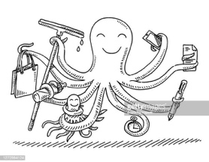



Kindness Respect Resilience Fairness Teamwork Ambition

Routines Matter

Children thrive on a sense of consistency and routine. For some children, school is the only place where they experience such stability. As such, we have some clear routines and expectations at the centre of our behaviour approach – setting the tone from the second that the children and families arrive at school.

These consistent routines and expectations are:

- Consistent arrivals (Detailed in appendix 1)
- Handale walking (Detailed in appendix 1)
- Lining up (Detailed in appendix 1)
- Constantly referring to our 3 school rules
- Consistent reward and recognition
- Consistent adult language and approach to behaviour Individual classroom routines

Clear Rules and Associated Language Matter

We have three, simple school rules which encompass all aspects of school life. These are explicitly taught and they are displayed in all key areas (poster in appendix 2). These rules are:

Work Hard, Aim High
Be Kind
Show Respect
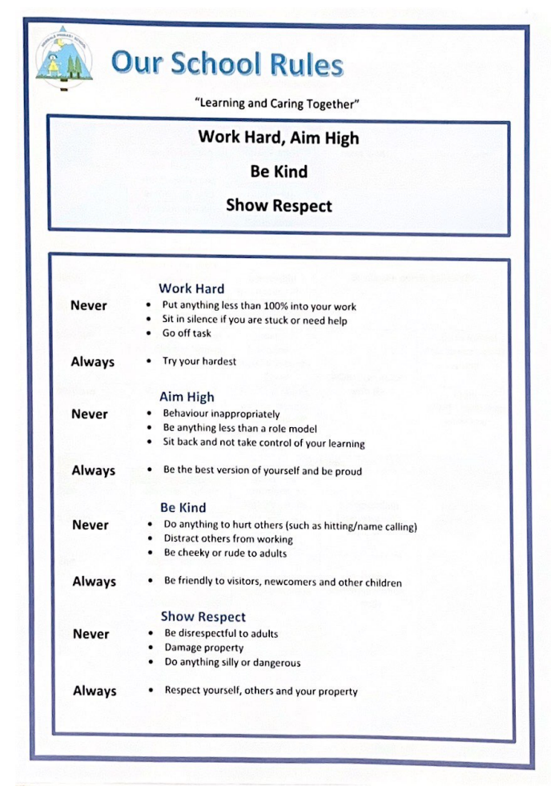
Rewards

House Points
Each child is allocated a house group from the day that they arrive at Handale Primary School. These groups are linked to family groups.

Children work towards achieving house points for themselves and their house group.

House Points can be awarded for:
- Doing the right thing
- Brilliant work and effort

Children can be awarded certificates for 50, 100, 200 and 500 House Points.

Each week, the house points are all totalled – with the winning house at the end of the term being awarded a treat (extra playtime, watch a cartoon etc).

In addition, children can also gain a place on the star board for following the three school rules. This is our method of teaching the children our rules, quickly and in depth.

Above and Beyond Bands
At Handale Primary School we recognise the children who go ‘Above and Beyond’ the school expectations. Children who stand out, at a particular time for doing special and more than is expected to simply follow the rules of the school. When an adult sees a child do this, they must recognise it – reward it, with an ‘Above and Beyond Band’. These bands are written on to say what they have done which is so amazing (so parents, staff and visitors can see).

On a Monday ‘Above and Beyond’ bands pupils will have lunch on a special table and go in first for dinners.

Individual children should not receive several of these each week; they are special and highly rewarded. Visitors are also able to recognise good behaviour and issue a wrist band.

Weekly Award Assembly

Pupil of the Week
On a Friday in whole school assembly, teachers recognise a child in their class who has worked exceptionally hard and followed the school rules. The children are rewarded with a small gift and a certificate to take home. The children are proud of their awards and then they have their photograph taken and posted on our school ‘Facebook’ page.

Star Board
On a Friday in whole school assembly, staff recognise pupils who have brought joy to the class and followed the school behaviour rules. The children identified will be added to the star display so everybody in school can identify good behaviour.

Attendance
On a Friday in whole school assembly, attendance is rewarded. The class with the best whole class attendance receives a reward of an extra playtime during the following week.

Consistency across the school is key at Handale Primary School.
Poor Behaviour Matters

In a primary school, children are not only learning to read, write and count – they are also learning to behave. As such, at times, most children will require their choice of behaviour to be checked or addressed.

Before this conversation happens, it is vital that the adult stops and considers:
- How would I speak to this child if their parent was on my shoulder?
- What would the best teacher in the world do?
- It is my professional responsibility to stay calm; I need to be mindful of my tone, body language and intonation.
- Children who struggle to behave take more time out of lessons – don’t give it to them in lessons too. Learning should not be impacted. Choose the time to speak to the child wisely.

At Handale Primary School, we have a clear, stepped approach to addressing a child who is not doing as we expect. In use of sanctions, children learn from experience to expect a fair and consistently applied punishment which differentiates between serious and minor offences.
Sanctions are applied consistently by all staff, but with the provision for flexibility to take account of individual circumstances.
Sanctions Procedure

We have an agreed system of sanctions which all staff must adhere to. Professional judgement is required regarding which step best reflects the most suitable sanction given for the behaviour displayed. Detention outside of school hours is not part of our agreed sanctions. In exceptional circumstances, depending on the nature of the offence, the sequence of sanctions will be bypassed resulting in fixed term or permanent exclusion.

All staff have the right to apply agreed sanctions up to and including Time Out C. More serious sanctions, such as playground exclusions or internal exclusions must be agreed in advance with a member of SLT/Learning Mentor.

As a general rule for minor and low-level behaviours the following sequence should be adhered to:

 | In Classroom | On Playground
Reminder | Remind the child that they are not following a school rule. This is a subtle behaviour management technique and is a quiet and low-key reminder of expected behaviours. It should be given as a polite reminder. Walk away to give time for the child to correct their behaviour, without an audience. | Remind the child that they are not following a school rule. This is a subtle behaviour management technique and is a quiet and low-key reminder of expected behaviours. It should be given as a polite reminder. Walk away to give time for the child to correct their behaviour, without an audience.
Step 1 Warning | If the behaviour continues, calmly remind – again, personally, with the consequences made clear. At this point, the child’s initials should be added to the classroom behaviour chart. This is not a ‘name and shame’ and should not be publicised to give notoriety – but the child needs to know that the stepped approach has started. | If the behaviour continues, calmly remind – again, personally, with the consequences made clear
Step 2 Last Chance | Inform children that this is their final warning. Children should be fully aware of what this means and the possible consequences of continuing with the behaviour. | Inform children that this is their final warning. Children should be fully aware of what this means and the possible consequences of continuing with the behaviour
From now on, no more warnings. Action is taken and behaviour is recorded on CPOMS
Time Out A | - Child is sent to a designated area of the classroom or outside of the classroom  - Child spends 10 minutes sitting alone in order to reflect, calm down without causing disturbance  - Child’s behaviour is recorded on the class behaviour log  For a regular offender at Time Out A (Regular = more than three times in two weeks) - Removal of treats/playtimes - Discussion with SLT to consider behaviour interventions | - Child is sent to a designated area of the playground  - Child spends 10 minutes sitting or standing alone in order to reflect, calm down without causing disturbance  - Child’s behaviour is recorded in class Behaviour log  For a regular offender at Time Out A (Regular = more than three times in two weeks) - Removal of treats/playtimes - Discussion with SLT to consider behaviour interventions
Time Out B | - Child is escorted to a designated colleague that is agreed in advance.  - Up to 1 hour working alone without causing disturbance  - Removal of playtime  - Child’s behaviour is recorded in Class Behaviour log  - Incident recorded on CPOMS  - Parents Contacted  For a regular offender at Time Out B (Regular = more than three times in two weeks)  - Discussion with SLT at SLT meeting - Involvement of SENCo  - Begin behaviour monitoring to identify triggers  - Parent meeting to agree support required - Consider recommendations from professional agencies  - Access to extra curricular/ enrichment linked to improvement | - Child is escorted to a Senior Leader  - Removal of playtime  - Takes place in HT/Learning Mentor office  - Child’s behaviour is recorded in Class Behaviour Log  - Incident recorded on CPOMS  - Parents Contacted
Time Out C | - Child is escorted to a Senior Leader (HT or DHT)  - One session or half a day working alone without causing disturbance  - Takes place in HT or DHT office  - Removal of playtime  - Child’s behaviour is recorded in Class Behaviour Log  - Incident recorded on CPOMS  - Parents contacted | Playground exclusion are for serious incidents, for example physical harm or aggression to another.  - Parents informed  - Recorded on CPOMS

Repair

It is the conversation about poor behaviour that changes it – not the punishment. Children need to know that if behaviour falls short of the standard expected by the school, that they will have to face it, during a ‘repair conversation’. This will be with the adult that imposed the time out and not during lesson time – it should be at a lunch or playtime. If the staff member requires cover for this – it should be prioritised. This is the chance for the adult and child to discuss the behaviour that led to the time out and any possible consequence or ‘imposition’ of it.

The fact that this conversation happened – and any key outcomes, should be recorded on CPOMS, if the adult deems it appropriate (e.g. a child not paying attention twice, which is out of character for the child and leads to a time out and conversation would not need to be recorded, but if an issue is becoming to be a pattern, or is leading to clear actions for the child or an intervention, it should be recorded).

In this meeting, it is vital that the adult is transparent as to whether parents will be informed.

The key ‘Repair Conversation questions’ are below, however 5 is enough, and less for young children (those in bold are most suitable for EY / KS1):

- What happened?
- What were you thinking at the time? (How XXX were you at the time, out of 10?) 3
- What have you thought since?
- How did that make people feel?
- Who has been affected (hurt/ upset for KS1)?
- How have they been affected?
- What should we do to put things right?
- How can we do things differently in the future?

Repeated or Serious Behaviour

If a child displays a behaviour that has serious consequences for others, such as a physical or verbal attack, racism or homophobia, we recognise that not only does the child require the support from school (and potentially other professionals) to address these behaviours, but also from home. As such, if a child carries out a serious behaviour incident, the staff member dealing with the incident can choose to escalate the sanction to Time out B or C as appropriate. A telephone call home or discussion with parents at pick up about such incidents, or call parents and carers, is expected by all staff.

Extreme Behaviours

Occasionally, some children may behave in an extreme way which is out of character for them, or poses a serious risk to the child, others or the harmonious running of the school.

Unacceptable behaviours may be expedited quickly through our behaviour system to be dealt with by a member of SLT. If this occurs a focused meeting involving SLT and the staff members will be arranged to discuss what happened and will follow the repair approach. Behaviours may include:

- Violence (i.e. physical contact made with the intention to harm)
- Repeat or Extreme defiance/ rudeness to any adult
- Persistent taunting, teasing and bullying
- Stealing
- Repeated Spitting
- Repeated Swearing

All such incidents and SLT repair meetings will be recorded on CPOMS.
Tracking Behaviour

Each week, each class has a ‘new sheet’ to track behaviours. This is a quick way to review low level issues and trends for cohorts and children. If a child is given a ‘Time Out’ – this is recorded and the brief reason noted on the back. If it is recorded on CPOMs, it does not need recording twice. Simply indicate there is a CPOMs record linked to the event. SLT review the tracking sheets each week to identify trends, CPD or individual children’s behaviours which are beginning to cause a concern.

Exclusion

When a child is excluded, for any length of time, they cannot be positively influenced by school; as such, it is not an approach taken lightly by the school. Importantly, however, a school must have procedures in place, by law, should the need or situation arrive. Our procedures are detailed within our Trust Exclusion Policy which is found here: https://www.lingfieldeducationtrust.com/trust-policies

Physical Interventions

Children should not require Physical Intervention unless they are posing an immediate risk to themselves, or others. As such, we have a full Physical Intervention Policy in place, based upon the best practice principles outlined in ‘Positive Environments, Where Children Can Flourish’ (OFSTED, 2018).
Behaviour in Our Community

Children who attend Handale Primary School are its ambassadors beyond the school day. As such, we would address inappropriate behaviour outside school if the following applied:
- The child was taking part in a school organised or a school related activity
- The child was on their way to or from school
- The behaviour could have repercussions in school
- The behaviour threatened another pupil of the school. Incidents outside school would be investigated fully and normal sanctions would be applied.
Parents and Carers

Parent and carers play a vital role in the management of pupil behaviour and have the right to know that their child is doing well or needs support. Parents are informed of good behaviour through our rewards systems – as well as the through the relationships that staff build with our families – catching parents on the yard, telephoning, emailing or using Marvellous Me are all appropriate ways to spread good news.
Equally if their child is behaving inappropriately at school, they must always be informed. It is preferable to inform the parent face to face about concerns, failing that a telephone call.
In cases of challenging behaviour, parents will be invited to meet with staff. At this meeting a school behaviour plan will be completed, including agreed Team Teach holds, if necessary, in line with the school Physical Intervention Policy.
Induction

Any new member of staff joining the school receives a copy and training of this policy.

Review

It is important that the school’s work with regard to behaviour is reviewed regularly – and by a range of stakeholders. Each year, staff, parents and children have the opportunity to review the success of the school approach, through discussion and questionnaire feedback. Annually, governors and school leaders review the policy in relation to this feedback. The policy also closely aligns to the Lingfield Education Trust Behaviour Principles, which can be accessed here: https://www.lingfieldeducationtrust.com/trust-policies

Signed: Headteacher

Signed: Chair of Governors

To be reviewed September 2024
Appendices

1 | Behaviour Blueprint
2 | Consistent Approach School Routines
3 | Our school rules
4 | De-escalation Techniques
5 | Pupil Behaviour, Positive Handling and Risk Assessment
6 | Class behaviour Log
7 | Lunchtime Rules

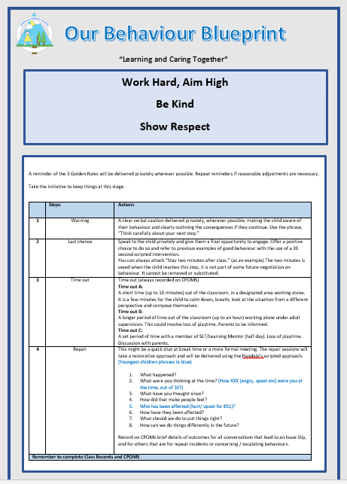
- Appendices

Appendix 1: Consistent School Routines
- Appendices

Arrival

- Children enter through the school gate which is always manned by a member of staff. Children will always be greeted by an adult at the gate and as they enter their classroom.
- Staff will always remember that they are there to welcome the children first. Children are expected to reply with to the adults with good morning
- On entry to the classroom children can choose to acknowledge the member of staff with how they are feeling by either showing a thumbs up or down, or some children may prefer to give a smile and a hug – but the adult must make every effort to interact with every child, setting the tone for the day.
- Children will always know ‘what to do’ when they enter the classroom – once their coat is
- hung up, children should have a learning task to settle down to before the day starts.
- Adults in the room should use this time to ‘check in’ with children – particularly those who
- may be most vulnerable.
Handale Walking

- The way that children move around the building and ‘carry themselves’ says so much about the expectations of the school. Get this right, the learning will transcend long beyond school and in to adult life.
- Handale walking relates to the school rules– we expect children to walk well independently of adult supervision.
- Walking confidently and with purpose is taught and expected, following these key points
  - Shoulders back
  - Head held high – I am proud to be me!
  - Hands by your side – not in pockets
  - We do not slide and lean along walls, or touch things as we walk past – we have
self-control
  - We are silent when walking through school – respecting others learning time
  - We smile and greet people in our path
  - We hold doors open and articulate ‘after you’
  - We always use our manners when people hold doors or let us through
  - We always walk on the left-hand side
  - Our Lining Up Code – lining up one behind the other with a space in between, no talking and show good listening
Lining Up at Handale

- The children are taught how to line up smartly, sensibly and in a straight line. In all year groups there should be a teacher at the front of the line and if possible a TA at the back, stopping at key points to reinforce
- Handale walking
- Hands by side
- One behind the other
- Showing good listening
- Showing good manners
- Keeping to the left
- We hold doors open
- The children are taught how to line up smartly, sensibly and in a straight line.
At the end of outdoor playtimes

- When whistle goes, children stop and show me 5- the adult will mirror this.
- When the whistle blows again, children walk to their line up area
- Children line up in ‘line-up order’
- All children follow our ‘Handale walking’ routine
- Adults to lead the line at break and lunchtimes
Classroom Routines

- Visitors are greeted with good morning or good afternoon
Carpet Expectations

- Sit on your bottom with your legs crossed
- Hands on your laps
- Show me good listening
- Eyes on me
- Give eye contact to whoever is talking
- Show me you are ready to learn
- Stand up
- Handale walking to your table
Table Expectations

- Sit your chair with both feet on the floor
- Sit up straight
- Chair tucked in
- Empty hands – to show respect
- Hands above the table
Tidy Up Routine

- It’s time to get ready to…
- All items to be returned to pencil cases or table storage
- Monitors to collect classroom resources
- Stand up
- Tuck chairs under
- Stand behind chairs with hands by their side
- EYFS – children to tidy areas following classroom expectations
Lunchtimes – Dining Hall

- Children to use knife and folk – with the exception of finger food
- Talk in a quiet voice
- Not to talk when eating
- Stand quietly waiting in the line
- Following follow expectations for ‘Lining up at Handale’

- Appendices

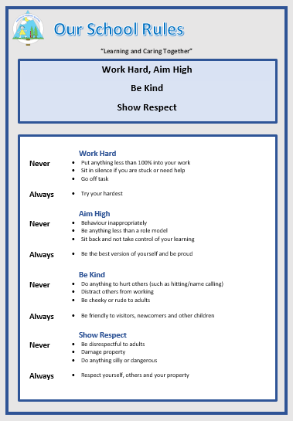

4. De-Escalation Techniques

Fresh face | Move back out of immediate range and let other staff/pupils become the focus
Reassurance | “I’ll always try to be here if you need me”  “Although that was wrong, we can help you put things right again”
Success reminder | “Remember that excellent number work you did for me this morning…”
CALM talking | In any potential confrontation, the first person who needs to calm down is the responsible adult.  Staff must maintain personal control.  Lower voice to help show that you are in control.
Distraction | Talk about something totally different (i.e. next weekend) to the child, or to another person.  Bring in something personal such as, “When I was talking to your mam on the phone…”  “Did you see East Enders last night?”  “Would you like a drink of water?”
Contingent touch | Sometimes a gentle touch on the forearm, hand, shoulder, etc works wonders. Any specialised touch or stroke needs to be formalised in the pupil’s Care Plan and signed by parent.
Reflective listening | “Focus on ‘feeling’ words….  - Note general content of message  - Observe body language  - Ask yourself, “If I were having that experience right now, what would I be feeling?”  - Reflect meanings. “You feel….because…
Humour | “Did you hear the one about….” Knock knock..
Planned Ignoring | If it isn’t upsetting anyone else…  Give a child ‘quiet time’ with no interaction other than reflection
Withdrawal offered | “Why don’t you go and finish that work in the library…”
Antiseptic Bounce | Message with ‘AB’ written at the top – this gives the child time out
Emphasise concern for welfare | “Are you alright? … Show me that hurt finger…oooh that must hurt a lot… Did you have a nice tea last night?
Help Script | ‘’Name’, I can see you’re upset/ angry …I’m here to help. Come with me. You talk, I’ll listen”

5. Pupil Behaviour, Positive Handling and Risk Assessment

Education Establishment  Handale Primary School | Assessor/Role
Name of pupil and D.O.B | Reason for Assessment | Date Reviewed

Diagnosis:

Pupil Profile | Always | Sometimes | Comments
Comprehension/Communication
Age appropriate
Limited/delayed
Compliance: |  | Details
Co-operative
Un Co-operative
Unpredictable
Positive handling needed
Behaviours: |  | Details
Verbal abuse
Threatening behaviour
Physical assault
Vandalism
Absconding
Theft
Defiance
Persistent disruptive behaviour
Unacceptable language
Other behaviours: |  | Details
Emotional/physical issues: |  | Details
Sensory issues
Anxiety/Emotional State
Meltdowns/Tantrums
Hypermobility
Fine/Gross Motor skills

Recommended Strategies:
Verbal Advice | Reassurance | Time Out Offered | Another Classroom | Negotiation
Step Away | Success Reminder | Distraction | Contingent Touch | Planned Ignoring
Humour | Fresh Face | Choices | Consequences | Reflective Listening
Space given | Antiseptic Bounce | Peer Mentor | Other (state)

Has a behaviour plan been completed? | Yes/No | Comments

Preferred Supportive Strategies

Verbal advice & support – using visuals |  | Contingent touch
Reassurance |  | Planned ignoring
C.A.L.M talking & stance |  | Time out offered
Time out directed |  | Fresh face
Humour |  | Choices/Limits/Consequences
Negotiation |  | Space given
Step away |  | Reflective listening
Success reminder |  | 3 part assertive message
Distraction (key words/objects/likes) |  | Antiseptic bounce
Brief description of supportive strategies e.g agreed use of language/consequences etc.

Preferred Handling Strategies (where necessary)

Caring C |  | Wrap hug Standing/Seated
Friendly hold |  | Double elbow standing/seated
Single elbow standing/seated |  | Half shield
Figure of four

Stepped Behaviour Strategies – Avoiding Escalation

Behaviour | Comments/Recommended Strategies | Level of risk to self- details  Low, Medium, high | Level of risk to peers- details  Low, Medium, high | Level of risk to staff- details  Low, Medium, high
DATE OF NEXT REVIEW:

SIGNED ASSESSOR: SIGNED LEADER:

SIGNED PARENT: DATE:

5. Behaviour Log

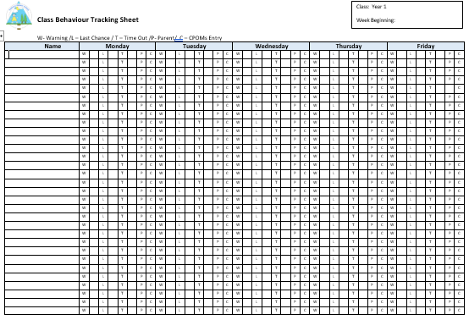
6. Lunchtime Rules

