This statement details our school’s use of pupil premium (and recovery premium for the 2022 to 2023 academic year) funding to help improve the attainment of our disadvantaged pupils.

It outlines our pupil premium strategy, how we intend to spend the funding in this academic year and the effect that last year’s spending of pupil premium had within our school.

School overview
Detail | Data
School name | Handale Primary School
Number of pupils in school | 185 (Reception – Year 6)
Proportion (%) of pupil premium eligible pupils | 83 pupils (45%)
Academic year/years that our current pupil premium strategy plan covers (3 year plans are recommended) | 2021/2022  2022/2023  2023/2024
Date this statement was published | October 2021
Date on which it will be reviewed | Reviewed October 2022  Next Review October 2023
Statement authorised by | Mrs Nicola Padgett  Headteacher
Pupil premium lead | Mrs Rio Farrier  Deputy Headteacher
Governor / Trustee lead | Miss Gemma Harrison  Lead for disadvantaged children
Funding overview
Detail | Amount
Pupil premium funding allocation this academic year | £113, 530
Recovery premium funding allocation this academic year | £9, 112.50
Pupil premium funding carried forward from previous years (enter £0 if not applicable) | £3, 793
Total budget for this academic year  If your school is an academy in a trust that pools this funding, state the amount available to your school this academic year | £126, 615.50

Part A: Pupil premium strategy plan

Statement of intent
Our intention is that all pupils, irrespective of their background or the challenges they face, make at least good progress and achieve high attainment across all subject areas. The focus of our strategy is to support disadvantaged pupils to achieve that goal, including progress for those who are already high attainers. First Quality teaching is the heart of our approach, with a specific focus on areas in which disadvantaged pupils require the most support. We believe this has the biggest impact on the development of the child and closing the disadvantage gap and at the same time will benefit the non-disadvantaged in school.

When making decisions about using Pupil Premium funding it is important to consider the context of the school and the subsequent challenges faced. Research conducted by EEF should then be used to support decisions around the usefulness of different strategies and their value for money. Our strategy is also integral to wider school plans for education recovery, notably in its targeted support through the National Tutoring Programme for pupils whose education has been worst affected, including non-disadvantaged pupils.

Common barriers to learning for disadvantaged children, can be less support at home, weak language and communication skills, attendance and punctuality issues, a lack of confidence and low self-esteem. There may also be complex family situations that prevent children from flourishing. The challenges are varied and there is no ‘one size that fits all.’

Our ultimate objectives are:
- To narrow the attainment gap in reading, writing and maths between disadvantaged and non-disadvantaged pupils, both in school and nationally through quality first teaching and increased opportunities for reinforcement of learning at home.
- For all disadvantaged pupils in school to make or exceed nationally expected progress rates.
- To support our children’s health and wellbeing to enable them to access learning at an appropriate level.

We aim to do this through:
- Ensuring that teaching and learning opportunities (including quality first teaching) meet the needs of all pupils.
- Use of termly data analysis to identify children falling behind.
- Ensuring that appropriate provision is made for pupils who belong to vulnerable groups, this includes ensuring that the needs of socially disadvantaged pupils are adequately assessed and addressed.
- Ensuring that disadvantaged pupils have access to a range of interventions in school to meet their SEND needs, identified on EHCPS and IPM (Individual Provision Maps).
- Pupil premium funding will be allocated carefully which will identify priority classes, groups or individuals. Limited funding and resources means that not all children receiving free school meals will be in receipt of pupil premium interventions at one time.
- Providing an effective pastoral support service for both pupils and parents, identified through school as vulnerable or in need. We aim for disadvantaged pupils to increase their attendance at school closing the gap between themselves and non-disadvantaged pupils and enabling them to experience the full learning experience we offer at Handale Primary.
- Identified targeted children on provision maps, PPG proformas and intervention impact sheets.
- Pupil progress meetings to discuss disadvantaged children including successes and any areas for further support to enable children to make expected progress.
- From 2022, school meals will be reduced to £1 per child.

Achieving these objectives:
- Ensuring all teaching in school is at least good ensuring that the quality of teaching experienced by all children is exceptional.
- Allocate a Teaching Assistant to each Year Group (classes over 20) – providing small group work focussed on overcoming gaps in learning, delivering catch up and same day interventions
- 1:1 support in the Small Learning Community for PPG with SEND.
- All of our work through the pupil premium will be aimed at accelerating progress, moving children to at least age-related expectations.
- Additional learning support.
- Supporting payment for activities, educational visits and residentials. Ensuring children have first-hand experiences to use in their learning in the classroom.
- Behaviour support.
- Pupil progress meetings and actions including interventions included.
- Pupil voice will highlight that children are enjoying school and are attending clubs and using our breakfast club offer.
- Parents will feel supported and believe that we are doing the best that we can for their children.

Challenges

This details the key challenges to achievement that we have identified among our disadvantaged pupils.
Challenge number | Detail of challenge
1 | Outcomes and progress of pupils are significantly affected by their SEND and home life. A significant percentage of population live in some of the most deprived areas in the country. Figures
2 | A high % of children enter nursery below the the age related expectations. Increased numbers of pupils with complex needs, including speech and language, social communication, poor working memory, attention difficulties, motor skills, social emotional and mental health.
3 | The education and well-being of many of our disadvantaged pupils have been impacted by partial school closures to a greater extent than for other pupils. These findings are supported by national studies. This has resulted in significant knowledge gaps leading to pupils failing further behind age-related expectations, especially in Maths.
4 | Our attendance data over the last 3 years indicates that attendance among disadvantaged has been between 2.8% and 6.7% lower than for non-disadvantaged pupils.  In 2020 – 2021 94.6% of disadvantaged pupils have been persistently absent compared to 94.7% of their peers during that period. Our assessments ad observations indicate that absenteeism is negatively impacting disadvantaged pupils.  2021 – 2022 attendance figures
5 | Assessments, observations and discussions with pupils suggest disadvantaged pupils generally have greater difficulties with phonics than their peers. This negatively impacts their development as readers and on the wider curriculum as reading is the key to learning.
6 | Pupils have limited life skills and cultural experiences beyond their home life and the immediate community. Lack of support from home due to parent’s academic ability and confidence.

Intended outcomes
This explains the outcomes we are aiming for by the end of our current strategy plan, and how we will measure whether they have been achieved.

Intended outcome | Success criteria
Pupils make at least expected progress in reading, writing and maths. | Gap will close in progress made between PP and non-PP.  Achieve national average progress scores in Reading, Writing and Maths. All pupil premium children will make good or outstanding progress. Teaching over time indicates that the ap is narrowing between PP and non-disadvantaged pupils.  KS2 reading, writing and maths outcomes in 2024/25 will show that at least 80% of disadvantaged pupils will have met the expected standard.
Pupils access a wide range of interventions to meet their SEND needs, including speech and language. | As their SEND needs are being addressed, PP pupils make expected progress or exceed their targets set in Reading, Writing & Maths.
Improved attitudes to learning. | Reduction of incidents reported on CPOMS.  Pupil surveys reflect enjoyment in school and improved attitudes to learning.  Social skills, independence, perseverance and team work are developed.  Sustained high levels of wellbeing from 2024/25 will be demonstrated by:  - Qualitative data from pupil voice, parent and pupil surveys and teacher observation  - A significant increase in participation in enrichment activities, particularly among disadvantaged pupils
Vulnerable pupils are well supported. | SLT and Mrs Tully support vulnerable pupils so that children feel safe and happy at school. They indicate that they enjoy school. Behaviour and attitudes are good.
Language and communication in Early years improves. | Early identification enables children with speech and language difficulties the opportunity through programmes to make quick and accelerated progress.
Improve life and cultural experiences. | All children experience a range of activities, both in and out of school to broaden cultural enrichment and provide an enjoyable and exciting curriculum.
PP attendance increases. | Attendance of identified PP pupils increases and the gap between PP and non-PP narrows.  Sustained high attendance from 2024/25 will be demonstrated by:  - Whole school attendance will be no less than 96.5%, and the attendance gap between disadvantaged pupils and their non-disadvantaged peers being reduced by 2%.  - The percentage of all pupils who are persistently absent being 92% and the figure among disadvantaged pupils being no more than 2% lower than their peers.
Support families in the community | Parents feel supported and raise any concerns with Mrs Tully (family support worker). Parents are gin posted to agencies hich will ease any difficulties which may arise.

Activity in this academic year

This details how we intend to spend our pupil premium (and recovery premium funding) this academic year to address the challenges listed above.

Teaching (for example, CPD, recruitment and retention)
Budgeted cost: £ 50, 369.00
Activity | Evidence that supports this approach | Challenge number(s) addressed
TA support in YR, Y1, Y2, Y3, Y4 and Y6 | - High quality focus groups delivered in Maths and English sessions by teaching assistants. | 1,2,3,5
CPD  Ensure all teachers receive high quality CPD in relation to developing evidence-based teaching strategies and pedagogy. For example, development of the outdoor curriculum. | EEF rating: High impact  Moderate cost. High evidence base.  Evidence suggests that the impact is greater for more vulnerable students and the older learners and those in a wilderness setting and studies of adventure learning interventions consistently show positive benefits on academic learning. On average, pupils who participate in adventure learning interventions make approximately four additional months progress There is also evidence of an impact on non-cognitive outcomes such as self-confidence. | 1,2,6,7
Purchase of a DfE validated Systematic Synthetic Phonic programme to secure stronger phonics teaching for all pupils. | Phonics approaches have a strong evidence base that indicates a positive impact on the accuracy of word reading (though not necessarily comprehension), particularly for disadvantaged pupils.  Choosing a phonics teaching programme - GOV.UK (www.gov.uk)  Phonics | EEF (educationendowmentfoundation.org.uk)  The evidence based DFE https://www.gov.uk/government/publications/the-reading-framework-teaching-the-foundations-of-literacy  Reflects the exact practice that our school aspires towards. | 1,2,3,6
Vocabulary development
We will fund teacher release time to share best practice within school.
Purchase fully decodable matched books to accompany the new phonics scheme.
Improve the quality of social and emotional (SEL) learning. (PSHCE)  SEL approaches will be embedded into routine educational practices and supported by professional development and training for staff. | There is extensive evidence associating childhood social and emotional skills with improved outcomes at school and in later life (e.g. improved attitudes, behaviour and relationships and improved academic performance.)  EEF https://d2tic4wvo1iusb.cloudfront.net/eef-guidance-reports/primary-sel/EEF_Social_and_Emotional_Learning.pdf?v=1635355221 | 4

Targeted academic support (for example, tutoring, one-to-one support structured interventions)
Budgeted cost: £54, 063.09
Activity | Evidence that supports this approach | Challenge number(s) addressed
- Quality first teaching for all pupils.  - TA CPD is ongoing for Maths and English by leads  - Maths is high priority on school development plan.  - Pupil Progress meetings track progress of PP pupils and appropriate, timely interventions are put in place. | - EEF guide to pupil premium – tiered approach – teaching is the top priority, including CPD.  - Training and supporting highly qualified teachers deliver targeted support. | 1,3,5,6
Purchase web-based programs to be used in school at home.  - Spelling Shed  - Lexia  - TTRS | EEF toolkit – parental engagement  EEF guide to pupil premium – targeted academic support  EEF – digital technology – clear evidence technology approaches are beneficia for writing and maths practice. | 1,3,5
Additional phonics sessions targeted at disadvantaged pupils who require further phonics support. | Phonics approaches have a strong evidence base indicating a positive impact on pupils, particularly from disadvantaged backgrounds. Targeted phonics interventions have been shown to be more effective when delivered as regular daily sessions over the year.  Phonics | EEF (educationendowmentfoundation.org.uk)  Choosing a phonics teaching programme - GOV.UK (www.gov.uk) | 1,2, 5
- HLTA delivers interventions 0.4 days a week to pupils identified as in need.  - TA’s deliver interventions 0.5 days a week to pupils identified as in need.  - Learning Mentor/Family Support Worker | EEF – oral language interventions consistently show positive impact on learning.  - High quality small group interventions  - Specialists lead CPD sessions with individual pupils and staff.  - Proven interventions are used, with evidence supporting the development in social skills, speech and language, behaviour and mental health.  - EEF – social and emotional learning – improves interaction with others and self -management of emotions – impacts on attitudes to learning and social relationships in school, which increases progress in attainment. | 1,2
Engaging with the National tutoring Programme to provide a blend of tuition, mentoring and school-led tutoring for pupils whose education has been most impacted by the pandemic. A significant proportion of the pupils who receive tutoring will be disadvantaged, including those who are higher attainers. | - Small group tuition is defined as one teacher or professional educator working with one to five pupils together in a group. This arrangement enables the teacher to focus exclusively on a small number of learners, usually in a separate classroom or working area. Intensive tuition in small groups is often provided to support lower attaining learners or those who are falling behind, but it can also be used as a more general strategy to ensure effective progress or to teach challenging topics or skills.  One to one tuition | EEF (educationendowmentfoundation.org.uk)  Small group tuition | EEF (educationendowmentfoundation.org.uk) | 1,3,5,6
To look into ELKLAN principles throughout nursery to develop communication and oracy skills.  Education Development Trust Training Early Years: Building on Success-Little Learners | The average impact of Oral language interventions is approximately an additional six moths progress over the course of the year. Some studies also often report improved classroom climate and fewer behavioural issues following work on oral language. Approaches that focus on speaking, listening and a combination of the two all show positive impacts on attainment. | 2,6

Wider strategies (for example, related to attendance, behaviour, wellbeing)
Budgeted cost: £ 22, 321.00
Activity | Evidence that supports this approach | Challenge number(s) addressed
- Full time/Part time Family Support Worker  - FSW contacts all new families as join, finds out needs and circumstances and offers support. Consent form filled in.  - Register of families and level of support required.  - PP families receive a weekly call off FSW and offers of support.  - Home visits  - Signposting for support  - HSLW attends TAF, CIN, CP meetings | Decrease in numbers of families in CIN, CP due to increase in families accessing early intervention from home school link worker.  Dedicated person in the role, who builds a relationship where the parents trust them and feels they will listen to them and provides them with the support they require, leads to improved relationships with school and home lives for the whole family.  EEF toolkit– Parental engagement  FSW – Mrs Tully  Improving Social and Emotional Learning in Primary Schools | EEF (educationendowmentfoundation.org.uk) | 2,3
- Training and release time for staff to develop and implement new procedures.  - Office staff phones families at 9am if pupil not in school and offers support.  - FSW and HT will pick up child from home if required.  - FSW works closely with attendance officer from LA, pupils below 96% are identified and protocols followed. | The DfE guidance has been informed by engagement with schools that have significantly reduced levels of absence and persistent absence.  Dedicated person who monitors attendance and who has a good relationship with parents is most effective at ensuring good pupil attendance.  Attendance interventions rapid evidence assessment | EEF (educationendowmentfoundation.org.uk)  Working with Parents to Support Children's Learning | EEF (educationendowmentfoundation.org.uk) | 4
- Cultural capital experiences promoted in the curriculum.  - Essential experiences built into curriculum planning  - Reduction in cost of trips for PP  - Residential trip cost is greatly reduced for PP  - Sports events /afterschool clubs promoted to PP are encouraged to attend  - Outdoor learning encouraged | Learning is contextualised in concrete experiences and language rich environments.  Ofsted research (2019) places emphasis on improving cultural capital, particularly for disadvantaged pupils.  Pupil surveys reflect greater enjoyment and engagement in school.  Enrichment activities offer children a context for leaning and a stimulus to trigger their interest which can be evidenced in pupil books and data.  EEF – sports participation increases educational engagement and attainment.  EEF – outdoor adventure learning shows positive benefits on academic learning and self -confidence.  Education Endowment Foundation | EEF  Working with Parents to Support Children's Learning | EEF (educationendowmentfoundation.org.uk) | 3,6
- Bungalow Project for wellbeing continue pastoral care/support | EEF – Wellbeing  The EEF states that ‘Improvements appear more likely when social and emotional approaches are embedded into routine educational practised and supported by professional development and training for staff. | 2,6
- Attendance at before/after school clubs and booster classes. | The EEF states ‘The evidence indicates that, on average, pupils make two additional months progress per year from extended school time and particular through the targeted use of before and after school programmes. There is some evidence that suggests disadvantaged pupils benefit more, making closer to three months additional progress | 1,3,4,6
- Early identification of PP in EY with parental support in place | EEF report states that ‘on average, early years interventions have an impact of five additional months progress and appear to be particularly beneficial for children from low income families. | 2,3

Total budgeted cost: £ 126, 753.09

Part B: Review of outcomes in the previous academic year

Pupil premium strategy outcomes
This details the impact that our pupil premium activity had on pupils in the 2020 to 2022 academic year.
Our internal assessments during 2021/2022 suggested that the performance of disadvantaged pupils was lower than in the previous 2 years in key areas of the curriculum. Despite being on track during the first year 2018/2019, the outcomes we aimed to achieve in our previous strategy by the end of 2021/2022 were therefore not fully met.
Our assessment of the reasons of these outcome points primarily to Covid-19 impact, which disrupted all out subject areas to different degrees. As evidence in schools across the country, school closure was most detrimental to our disadvantaged pupils, and they were not able to benefit from our pupil premium funded improvements to teaching and targeted interventions to the degree we had intended. The impact was mitigated by our resolution to maintain a high quality curriculum, including during periods of partial closure, which was aided by the use of online daily teaching and resources such as White Rose Maths and Oak National Academy.
Aim | Outcomes
All underachieving children will be identified and addressed through assessment for learning strategies within lessons. Their needs will be addressed through marking and feedback and follow up interventions. | We achieved:  Same day intervention target gaps in learning from previous lessons – linked to basic skills in English and Maths.  Provision Maps were updated termly and interventions were recorded.  Pupil progress meetings highlighted progress pupils were making and identified net steps.  Tutoring Programme was used effectively with Year 1, Year 3 and Year 6 pupils in reading.  Pre-teaching interventions provide opportunities to rehearse skills in advance.  All vulnerable children offered a place during national lockdown January to March 8th.  Higher involvement with parents during lockdown.  Impact of the NTP
Children who have social and emotional difficulties in school are identified swiftly. They have access to early intervention to provide suitable support. School provides a positive and safe environment for these children. | We achieved:  FSW (Mrs Tully) worked effectively with families and targeted individuals.  Edukit surveys were completed, analysed and support was put in place.  Daily PSHE sessions took place during the school day after returning from the Spring Term lockdown.  Teachers identified pupils who needed early intervention.
Year 1 pupils with low starting points in social and emotional development, physical development, phonics/reading and maths to be well supported to make strong progress. | We achieved:  Phonics progress was strong during the Summer Term and interventions were delivered effectively by the Y1 teacher and teaching assistants.  Pupils were identified on provision maps and interventions were put in place in the Summer Term. CPD for staff on how to deliver successful interventions.  A new maths scheme was introduced to ensure that all pupils are given the opportunity to succeed.  Impact of the NTP
The teacher and teaching assistant will have to work effectively together to ensure the correct support and provision is provided. | We achieved:  Strong relationships were maintained between teachers and teaching assistants to support the needs of identified pupils. Interventions were planned carefully and focused on the gaps in pupils knowledge.
Provide the right support for disadvantaged pupils who are completing remote learning at home. Provide enough support for pupils to continue learning at home daily if there is a bubble closure or another lockdown. | We achieved:  We changed the way we delivered home learning during the second lockdown and this was proven to be successful.  Teachers taught daily on zoom and video lessons were provided to support the children throughout their timetable during the school day.  Learning at home matched the learning that would have been completed in school.  Vulnerable pupils were invited into school.  HT and FSW worked effectively to monitor attendance and complete home visits.
Bungalow Project – Targeting specific needs to improve social and emotional barriers | We achieved:  This was very successful throughout the school and targeted children worked 1:1 with the therapist to target needs. Feedback and communication was positive between pupils, school and parents.
Resourcing and selecting a new Phonics Programme | We achieved:  We bought into Little Wandle phonics scheme (Revised Letters and Sounds). All staff received training and all resources were bought. A Little Wandle action plan was created to show how the programme would be implemented into our school from September 2022
Improve Progress and Attainment for disadvantaged children. | We achieved:  Boosters and catch up sessions were delivered by teachers and were a huge success impacting on pupils achievements.

Data 2021 2022
Aim | Outcomes
To narrow the gap in phonics compared to national fugures. | School data shows that the children performance was above the TSDS Average. However disadvantaged boys performed worse than disadvantaged girls (1 boy).  Awaiting national data
Phonics Data
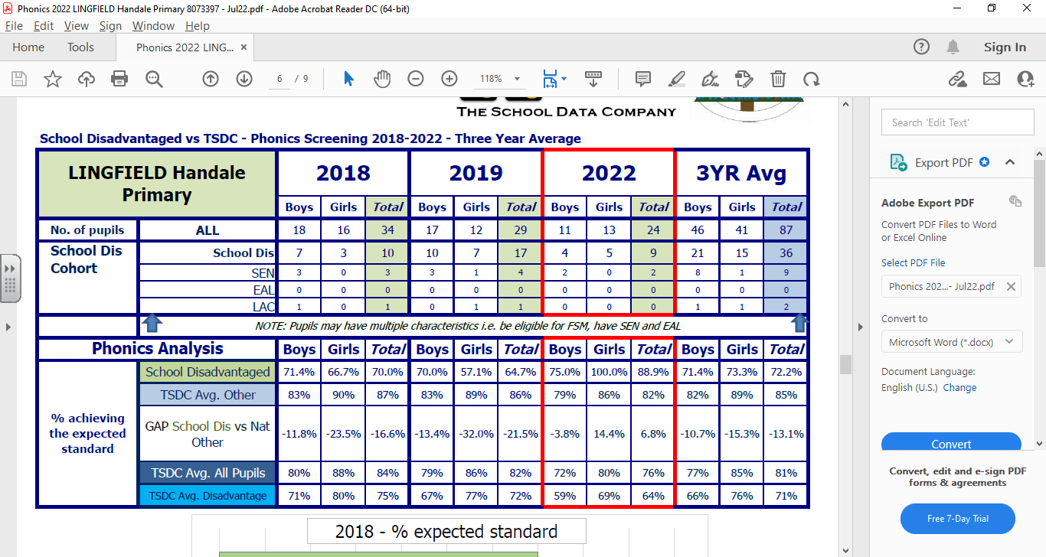
Disadvantaged children in Key Stage 2 will perform in line with or above the national average. | School data shows that the children performance was above the TSDS Average in reading and writing however it is below in maths.  Awaiting national data
Key Stage 1 Data

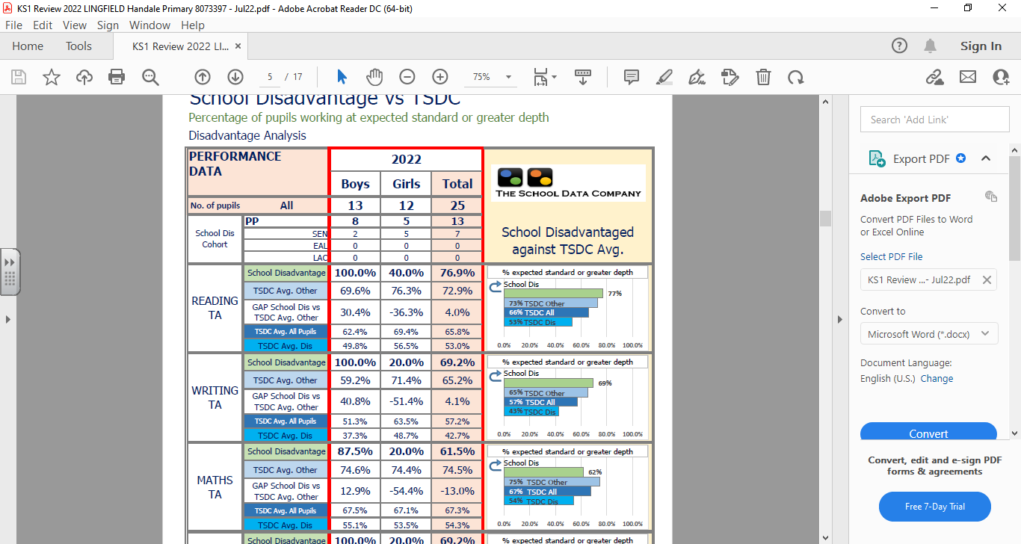
Disadvantaged children in Key Stage 2 will perform in line with or above the national average. | Reading – Disadvantaged children performed better than TSDC national average.  GPS – Disadvantaged children performed slightly lower the TSDC national average.  Writing – Disadvantaged pupils performed slightly lower than TSDC national average.  Maths – Disadvantaged pupils didn’t perform as well in Maths. Only 62% of disadvantaged pupils achieved the expected standard compared to 81% (TSDC national average).  RWM combined – This was significantly lower than the average of disadvantaged pupils (TSDS national average)  The data shows us that our pupils are still not performing in line with national by the end of KS2.
Key Stage 2
