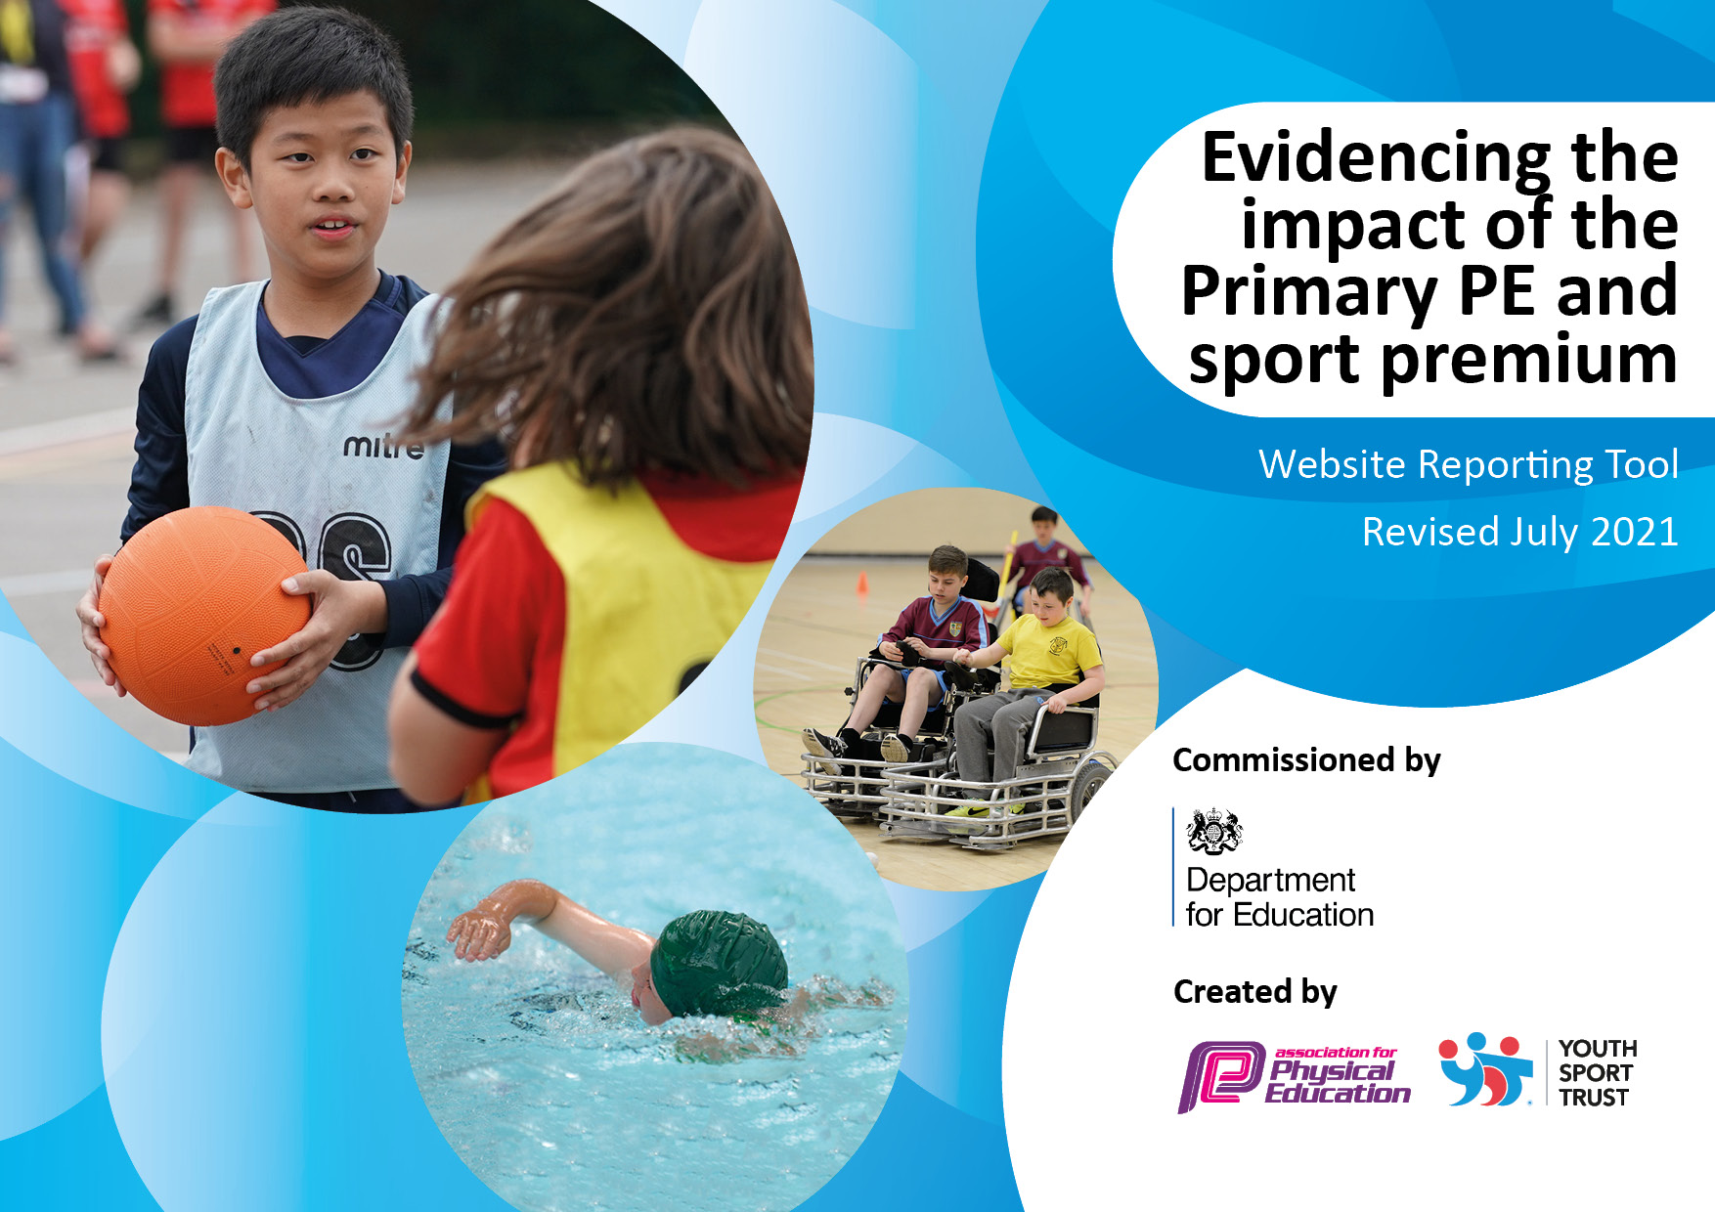
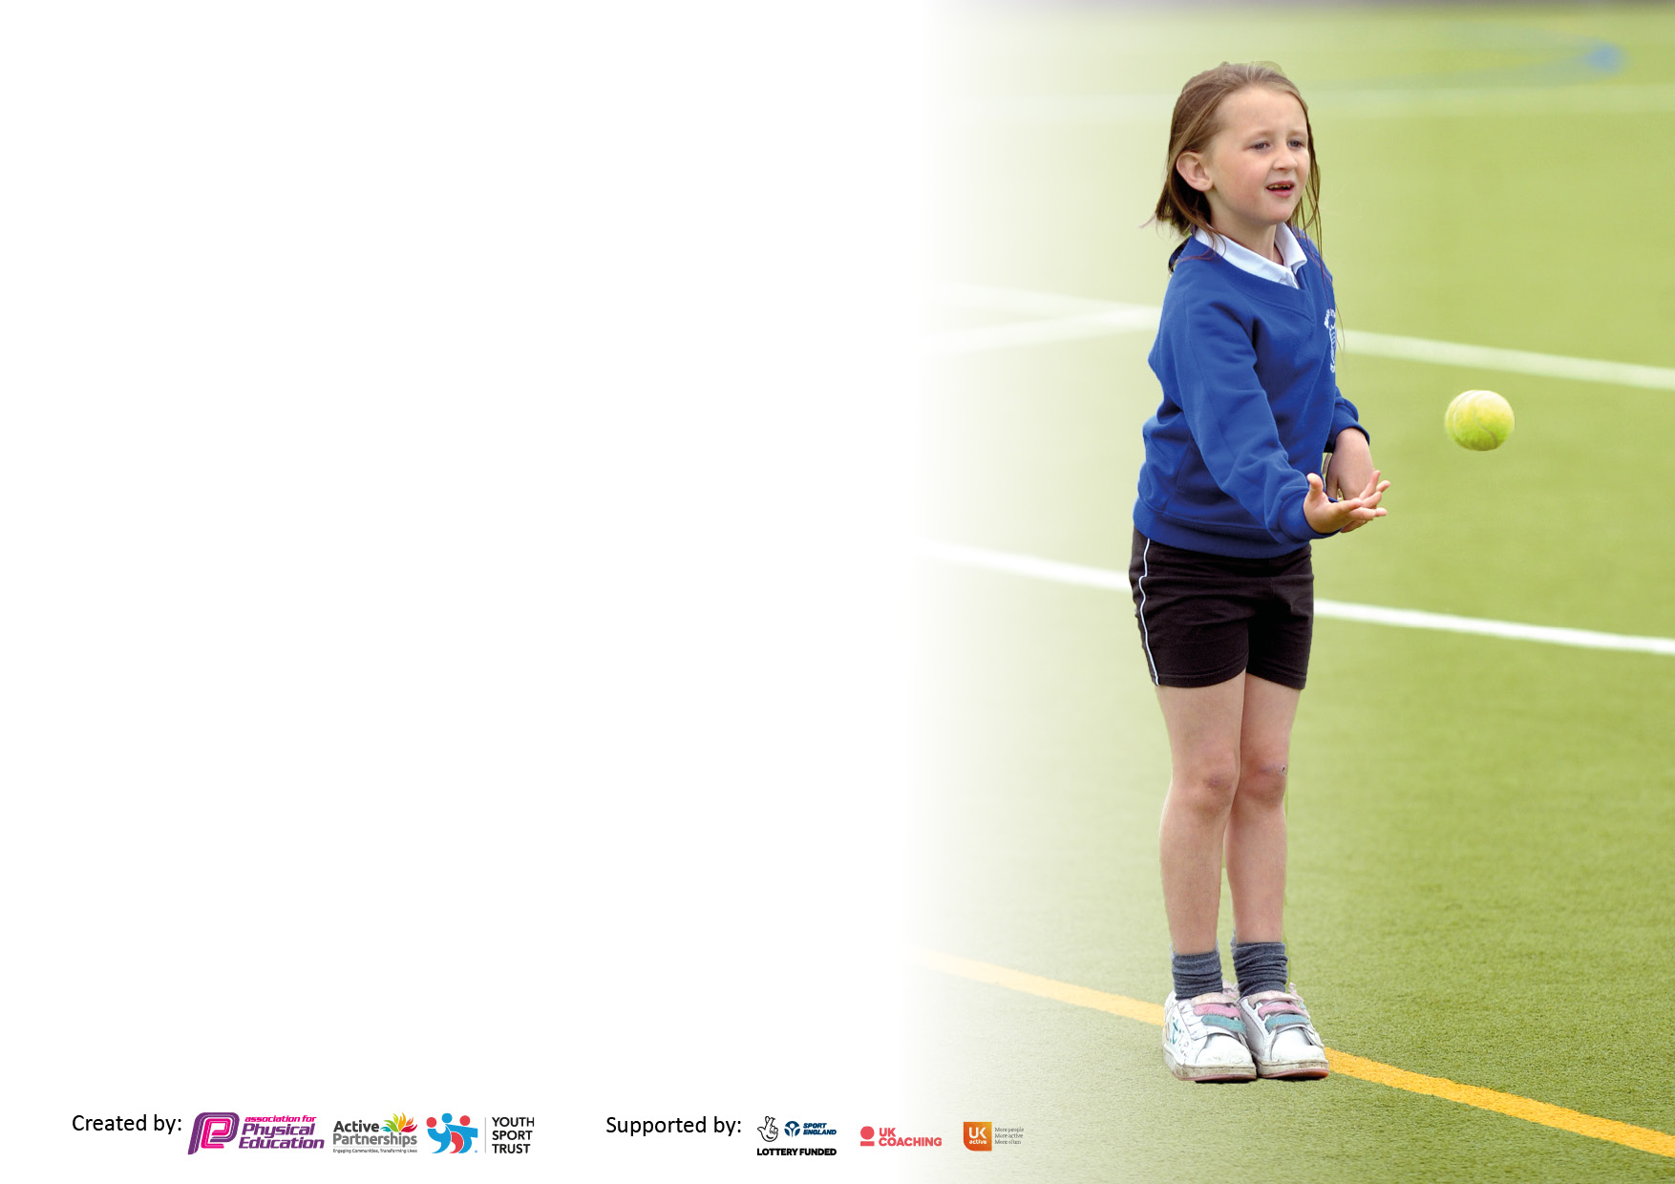

It is important that your grant is used effectively and based on school need. The Education Inspection Framework makes clear there will be a focus on ‘whether leaders and those responsible for governors all understand their respective roles and perform these in a way that enhances the effectiveness of the school’.

Under the Quality of Education Ofsted inspectors consider:
Intent - Curriculum design, coverage and appropriateness
Implementation - Curriculum delivery, Teaching (pedagogy) and Assessment
Impact - Attainment and progress

To assist schools with common transferable language this template has been developed to utilise the same three headings which should make your plans easily transferable between working documents.

Schools must use the funding to make additional and sustainable improvements to the quality of Physical Education, School Sport and Physical Activity (PESSPA) they offer. This means that you should use the Primary PE and sport premium to:

- Develop or add to the PESSPA activities that your school already offer
- Build capacity and capability within the school to ensure that improvements made now will benefit pupils joining the school in future years
- The Primary PE and sport premium should not be used to fund capital spend projects; the school’s budget should fund these.

Pleasevisitgov.ukfortherevisedDfEguidanceincludingthe5keyindicatorsacrosswhichschoolsshoulddemonstrate animprovement.Thisdocumentwillhelpyoutoreviewyourprovisionandtoreportyourspend.DfEencouragesschools to use this template as an effective way of meeting the reporting requirements of the Primary PE and sport premium.

We recommend you start by reflecting on the impact of current provision and reviewing the previous spend.

Schools are required to publish details of how they spend this funding, including any under-spend from 2019/2020, as well as on the impact it has on pupils’ PE and sport participation and attainment. All funding must be spent by 31st July 2022.

We recommend regularly updating the table and publishing it on your website throughout the year. This evidences your ongoing self-evaluation of how you are using the funding to secure maximum, sustainable impact. Final copy must be posted on your website by the end of the academic year and no later than the 31st July 2021. To see an example of how to complete the table please click HERE.


Created by: Supported by:

Details with regard to funding
Please complete the table below.

Total amount carried over from 2021/22 | £0
Total amount allocated for 2022/23 | £17,660
How much (if any) do you intend to carry over from this total fund into 2022/23? | £0
Total amount allocated for 2022/23 | £17,660
Total amount of funding for 2022/23. To be spent and reported on by 31st July 2023. | £22, 300 (extra funding provided by school budget)
Swimming Data
Please report on your Swimming Data below.

Meeting national curriculum requirements for swimming and water safety.  N.B. Complete this section to your best ability. For example you might have practised safe self-rescue techniques on dry land which you can then transfer to the pool when school swimming restarts.  Due to exceptional circumstances priority should be given to ensuring that pupils can perform safe self rescue even if they do not fully meet the first two requirements of the NC programme of study | 20/27  74%
What percentage of your current Year 6 cohort swim competently, confidently and proficiently over a distance of at least 25 metres?  N.B. Even though your pupils may swim in another year please report on their attainment on leaving primary school at the end of the summer term 2021.  Please see note above | 18/27  67%
What percentage of your current Year 6 cohort use a range of strokes effectively [for example, front crawl, backstroke and breaststroke]?  Please see note above | 25%
What percentage of your current Year 6 cohort perform safe self-rescue in different water-based situations? | 0%
Schools can choose to use the Primary PE and sport premium to provide additional provision for swimming but this must be for activity over and above the national curriculum requirements. Have you used it in this way? | Yes

Action Plan and Budget Tracking
Capture your intended annual spend against the 5 key indicators. Clarify the success criteria and evidence of impact that you intend to measure to evaluate for pupils today and for the future.

Academic Year: 2020/21 | Total fund allocated: | Date Updated:
Key indicator 1: The engagement of all pupils in regular physical activity – Chief Medical Officers guidelines recommend that primary school pupils undertake at least 30 minutes of physical activity a day in school |  |  |  | Percentage of total allocation:
 |  |  |  | %
Intent | Implementation |  | Impact
Your school focus should be clear what you want the pupils to know and be able to do and about  what they need to learn and to  consolidate through practice: | Make sure your actions to achieve are linked to your intentions: | Funding allocated: | Evidence of impact: what do pupils now know and what can they now do? What has changed?: | Sustainability and suggested next steps:
All pupils receive two hours of timetabled PE each week and have access to: lunchtime activities, trim trail at break time and morning motivate before school (1 hour a day). The profile of the trim trail has been raised with regular pupil activity being observed.  Continue to encourage greater Physical Activity in our children, to empower children to make positive healthy lifestyle choices.  To increase the children’s activity levels in response to their recent decrease due to lockdown.  IMPACT ON PUPILS  Increased access to and involvement in physical activities at school lunchtime. Therefore activity levels increased daily.  Develop positive attitudes towards health and fitness, and develop social and emotional well-being through physical activity. Readiness to learn following physical activity.  To provide extra PE curriculum PE Clubs both at lunchtime and after school. In order to develop skills and improve provision.  To ensure children who have previously accessed swimming lessons and have not achieved the expected standard by Year 5/6 will access extra sessions. | PE co-ordinator (R Farrier) to continue to raise the profile of sport across the school for all pupils not just those who enjoy sport.  Timetables to be reviewed termly to maintain two hours of PE a week.  Plan and deliver a range of sporting activities during sports week.  Continue targeting different children for C4L after school club which is to be delivered in summer term.  Give SEN and PPG children equal opportunities in sport.  Target all KS2 children to attend after school or out of school sporting clubs.  Every child is recognised for their attending a sports event via marvellous me.  To employ sport coaches after school to offer structured sports clubs  Teachers, TA’s and external sporting providers to provide extra clubs after school.  To audit PE equipment linked to extra-curricular activities and purchase new equipment as required.  Increase the number of clubs available for the children to attend.  Lunchtime supervisors received CPD from our sports lead to help them keep children active at lunch time.  Update play equipment for playleaders to lead effectively.  Pupils to be trained as playleaders to lead play at lunchtimes.  To provide children with extra sessions to ensure they meet the minimum requirements before leaving primary school. | £600  £8000  £2000  £1000  £100  £200  £0  £2000
Key indicator 2: The profile of PESSPA being raised across the school as a tool for whole school improvement |  |  |  | Percentage of total allocation:
 |  |  |  | %
Intent | Implementation |  | Impact
Your school focus should be clear what you want the pupils to know and be able to do and about  what they need to learn and to  consolidate through practice: | Make sure your actions to achieve are linked to your intentions: | Funding allocated: | Evidence of impact: what do pupils now know and what can they now do? What has changed?: | Sustainability and suggested next steps:
To improve social skills, behavioural development and academic achievement through access to broadened and improved physical education and activity provision, leading to increased health and well-being of all children.  IMPACT  To develop leadership skills in pupils  Develop life skills in pupils  Celebrate sporting success through the school sports games website.  Celebrate sporting achievements using our PE recognition board in school.  To purchase a PE scheme where it extends the provision in school supporting teachers to develop their skills and knowledge.  To work towards achieving the gold standard Games mark award. | Promote through assemblies, Twitter, Facebook and the school website.  Sports lead in school to training up sports leaders in Year 5/6 who will then lead PE sessions to the rest of school during lunchtimes.  Leaders will also support sporting events in school such as sports week.  Subject lead to continue to work with Cleveland Sports Partnership and attend training.  Purchase a PE scheme which will increase capacity of teachers knowledge and skills.  Complete an audit of the quality against the criteria required. | £100 (advertising)  No cost  No cost  £3000+ release time £1000  £1000  No cost

Key indicator 3: Increased confidence, knowledge and skills of all staff in teaching PE and sport |  |  |  | Percentage of total allocation:
 |  |  |  | %
Intent | Implementation |  | Impact
Your school focus should be clear | Make sure your actions to | Funding | Evidence of impact: what do | Sustainability and suggested
what you want the pupils to know | achieve are linked to your | allocated: | pupils now know and what | next steps:
and be able to do and about | intentions: |  | can they now do? What has
what they need to learn and to |  |  | changed?:
consolidate through practice:
To improve the quality of teaching in PE through staff CPD and new scheme and assessment structure, to further enhance staff competence and confidence in planning, teaching and assessing PE.  IMPACT  Staff to use the new PE scheme to support them in the delivery of PE skills and knowledge.  To improve engagement of children in the curriculum and provide teachers with fresh ideas  Assessment of PE is moderated and quality assured across the school. | PE lead and teachers to attend PE training/coaching and cascade to all staff.  External Providers delivering high quality PE lessons, as well as staff training.  Dedicated leadership time for PE (subject leader) | £300 release  Linked to indicator 1  £ 200 per term
Key indicator 4: Broader experience of a range of sports and activities offered to all pupils |  |  |  | Percentage of total allocation:
Intent | Implementation |  | Impact
Your school focus should be clear | Make sure your actions to | Funding | Evidence of impact: what do | Sustainability and suggested
what you want the pupils to know | achieve are linked to your | allocated: | pupils now know and what | next steps:
and be able to do and about | intentions: |  | can they now do? What has
what they need to learn and to |  |  | changed?:
consolidate through practice:
To extend the range on offer in during and out of school hours.  To broaden the offer to pupils.  IMPACT  Opportunities to enhance their knowledge and understanding of different sporting activities  Provide the pupils with positive sporting role models  Enhance outdoor learning further with an emphasis on physical and mental wellbeing  Deliver a range of different/unique sporting opportunities during sports week. Offer all children an opportunity to participate in a physical activity after school club.  Use bus companies to transport children to future sporting events. | To use qualified coaches to deliver specific PE clubs  To contact external agencies to run after school clubs and increase the range and sports on offer after school.  Organise activities outside of term time in line with Holiday clubs.  To develop the skills of a teacher to lead the subject through school and provide them with some release time to begin to develop plans in school.  Hire the services of unique sporting activities during sports week.  Cost of transport for children to attend the events | £4000 to funded through a grant offer  External Grant  £300 per year release  £1000  £2500

Key indicator 5: Increased participation in competitive sport |  |  |  | Percentage of total allocation:
 |  |  |  | %
Intent | Implementation |  | Impact
Your school focus should be clear | Make sure your actions to | Funding | Evidence of impact: what do | Sustainability and suggested
what you want the pupils to know | achieve are linked to your | allocated: | pupils now know and what | next steps:
and be able to do and about | intentions: |  | can they now do? What has
what they need to learn and to |  |  | changed?:
consolidate through practice:
To continue to be associated with Cleveland Sports Partnership to be involved in competitive sporting events across the county. | To participate in competitions through Cleveland Sports Partnership  Promote sport and competitions through a central board and through social media  Take part in local leagues for different sports | Refer to indicator 2

Signed off by
Head Teacher: | Nicola Padgett
Date:
Subject Leader: | Robbie Farrier
Date:
Governor: | Darren Fowler
Date:

