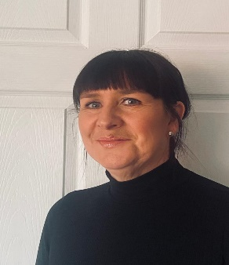
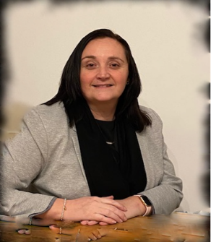
Handale Primary School
Safeguarding Children
Handale Primary School is committed to ensuring the well-being of every child and keeping them safe from emotional, mental and physical harm. Policies and procedures for safeguarding children and child protection can be accessed using:
www.handaleprimaryschool.co.uk
or
Miss Tully
Family Support
Mrs Padgett
Head Teacher
https://www.teescpp.org.uk/contact/redcar-cleveland
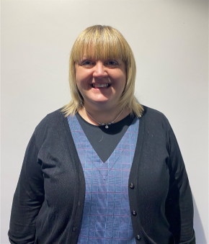

or via Redcar and Cleveland Multi-Agency Children’s Hub (MACH)
Tel: 01642 130700
During working hours: Monday to Thursday 8.30am – 5pm Friday 8.30am – 4.30pm
Tel: 01642 130700
Email: RedcarMACH@redcar-cleveland.gov.uk
Out of hours:
Emergency Duty Team
Tel: 01642 524 552
Mrs Lister
Assistant Head
Mrs Farrier
Deputy Head

In an emergency contact Cleveland Police on: 101


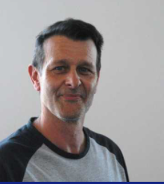
Alternatively, you may speak confidentially to a designated person in school. The designated person with overall responsibility for child protection is:

Mrs Nicola Padgett

Head Teacher

If you have concerns about safety in around Handle Primary School please contact Mr Caley, premises Site Manager on:

Tel: 01287 640416
Mr Blackburn CEO
Lingfield Trust
Mr Fowler
Chair Governors
If you have any concerns regarding the Headteacher, please contact Mr Blackburn CEO, information can be found at www.lingfieldeducationtrust.com

