 | Autumn 1 | Autumn 2 | Spring 1 | Spring 2 | Summer 1 | Summer 2
English | Narrative  The Queen’s Knickers  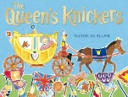  Non-Fiction  Recount – Diary  Samuel Pepys Diary   | Familiar Novel  The Day the Crayons Quit  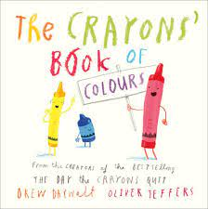  Non-Fiction  Instructions | Narrative Form  Recount  Pirates of Scurvy Sands  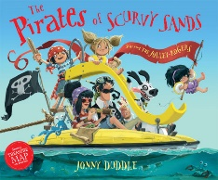  Non-Fiction  Non-Chronological Report  Pirates | Modern Story  Grandad’s Island  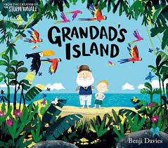  Non-Fiction  Persuasive Poster | Personal Experience  The Rainbow Bear  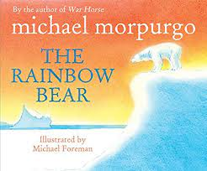  Non-Fiction  Real Events Recount | Classic Novel  Snow White  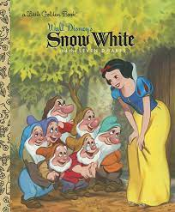  Non-Fiction  Non-Chronological Report  Florence Nightingale
Geography |  | Wonderful World/Magical Mapping |  | Sensational Safari |  | The Seaside
History | The Great Fire of London |  | Exploration |  | Medical Advancements
Art |  | Drawing /Printing  Are all cities dull?  Paul Klee/Stephen Brown |  | Painting  Can you paint a rainbow animal?  Paul Klee/Stephen Brown |  | Sculpture/Collage  Can the natural world be art?  Andy Goldsworthy
Design and Technology | Structures  Free Standing Structures  Design and build a house |  | Textiles  Templates and Joining Techniques  Glove puppet/Finger puppets |  | Mechanisms  Wheels & Axels  Create a mechanism for nurses to use
Music | Unit 1 Hands, Feet, Heart | Unit 2 Ho, Ho, Ho | Unit 3 I want to play in a band | Unit 4 Zootime | Unit 5 Friendship Song | Unit 6 Reflect, Rewind, Replay
Science (Discrete) | Biology  Living Things and their Habitats | Biology  Animals including Humans | Biology  Plants |  | Chemistry  Materials
PE | Dance  Team Building | Gymnastics  Health and Well-Being | Ball Games  Net Games | Hands  Games for Understanding | Athletics | Rackets, Bats and Balls
RE | Christianity  What did Jesus teach? | Christianity  Jesus as a gift from God | Islam  Passover | Christianity  Resurrection | Islam  The Covenant | Islam  Rights of Passage and Good Works
Computing | Computing systems and networks  IT around us | Creating media Digital Photography | Creating media Making Music | Data and information  Pictograms | Programming A  Robot algorithms | Programming B  An introduction to quizzes
PSHE | Being Me in the World | Celebrating Differences | Sex and relationship education Boys and girls, families | Sex and relationship education Boys and girls, families | Keeping safe and managing risk Indoors and outdoors | Drug, alcohol and tobacco education Medicines and me

