

A few words from Mrs Padgett…

Last term was only a short one of 5 weeks but we certainly packed a lot into it.

During the term we offered a staggering 11 after school for our children to enjoy after school, with a wide range of activities on offer. It has been wonderful to see over 150 children attending these each week. Next term there will be even more on offer thanks to the hard work of Mr Farrier organising more! Watch out for the new activities Handale will be offering to the wider community. We would like to thank everybody for completing the questionnaire to help us with this.

Lunches

Thank you for your patients during the transition to a new lunch system. The new system seems to be working much more accurately than the previous one.

Handale Primary School

Newsletter 8th February 2024

Please can we remind everyone to send in healthy snacks and packed lunches for children. It is vital that children are eating nutritious snacks and packed lunches at school. This will help children to stay fit and healthy; focus in lessons and thrive socially and emotionally. May we also remind you that we are a nut- free school. If you would like any further advice or ideas for healthy packed lunches, please do not hesitate to contact the school. If your child has a school lunch, please make payments through ParentPay. ***Meals cost £2.30 per day or £11.50 per week***.

If children are wanting to change from dinners to packed lunches or vice versa, the office require half a term notice please as food orders are placed in advance. Thank you.

We are aware that home circumstances change. If this happens school are able check to see if your child is entitled to free school meals. All that is required is your national insurance number and the date of birth of the parent. If you think this might be the case, please nip into the office and we can apply for you. If your child is entitled then they will receive this for the next 6 years.

[Online FSM Application (cloudforedu.org.uk)](https://apply.cloudforedu.org.uk/ofsm/sims)

All uniform is available to purchase on Lollipops Children's Clothes website.

Uniform

[www.lollipops-middlesbrough.co.uk](http://www.lollipops-middlesbrough.co.uk)

**We have noticed a number of children coming to school in unsuitable footwear, school policy stipulates black shoes or plain black trainers. If you need any support with uniform please see Miss Tully or Mrs Padgett, who will be happy to help.**

**Please could you check, children should not be coming to school wearing jewelry, this is for their safety. We will be asking children to remove these items in school. Please leave bracelets and earing at home.**

On-Line Safety



In school we are increasingly dealing with issues that have occurred on social media out of school. We support our pupils in giving them the information and skills to stay safe. This is one of them below.

**Report on Snapchat:**

You can always report abuse on Snapchat, including harassment, bullying or any other safety concern. If someone is making you uncomfortable, you can also block that Snapchatter and leave any group chat. To report a Snap, press and hold on a Snap or Story and then tap the “Report Snap” button.

Resource page: Check out Snapchats Safety Centre for a full list of safety partners and resources for young people

[Snapchat Support](https://help.snapchat.com/hc/en-gb) portal

<https://help.snapchat.com/hc/en-gb>

[Snapchat Support](https://help.snapchat.com/hc/en-gb)

Children’s Mobile Phones

We are aware that more of our children are bringing mobile phones into school as they feel more secure walking to and from home with them. School policy is that all mobiles are either handed into the school office on a morning or locked away in the classroom’s lockable cupboard. This is for safeguarding reasons. Please could you discuss this with your child if they bring their phone into school.

We currently have an amazing team of Year 4/5 children training to be Mental Health Ambassadors for our school. The children will then leave mental health activities in school supporting everybody.

World Book Day

Mental Health Ambassadors

**On Thursday 7th March**, we will be celebrating World Book Day in school. We have something very EXCITING planned for the children however we are keeping this a secret until the day. We will keep you updated with pictures and information!

As always, the children are invited to come to school dressed as their favourite book character **or this year they have the option to come dressed as something or someone from space**. Every year group will be completing different reading and writing tasks throughout the day linked to a Space Book.

We are really looking forward to the day and we know the children will love it. We wanted to give you plenty of notice so you have time to prepare your child’s costume. If you need any help with this, please let us know as we have a selection of costumes in school.

Careers Week

During week commencing 4th March we will be hosting activities and visiting speakers linked to a range of different careers. The week shines a spotlight on the importance of high-quality careers education and will provide opportunities for our children to engage with the world of work. It is important that children understanding that what interests them in school can turn into a career further on in their lives.

Next week sees the start of the resurfacing work on West Road with access limited to Hummersea and Liverton Mines. As this is going to cause some problems getting to and home from school we will open school from 8am all of next week to allow parents to drop children off earlier to avoid the congestion. I believe the times of closure will be from 9am until 3pm.

Maternity Leave

Road Works

We would like to wish Miss Kentfield-Howe well as she embarks on her new journey of motherhood, she will be amazing. Watch this space for further news!

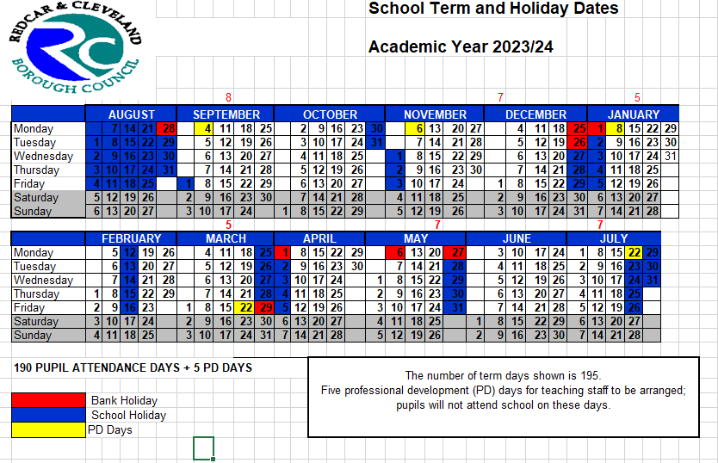As a reminder, please see below holidays for the Academic Year 2023/2024. Holidays should only be booked within these dates. No holidays will be authorised outside of these dates unless they meet the special circumstance criteria. If you are intending to take holidays during term time please make sure you complete a holiday form so we know where your child is. This is imperative to ensure our safeguarding procedures are followed.

Holidays in Term Time and Unauthorised Absences

Concerned About a Child?

Did you know that there is a number to call if you have any concerns about

the welfare of a child. You can share these concerns anonymously so you

shouldn't be put off by concerns that your identity would be known. It may

help a child in need if you take the time to pick up the phone and call the

Did you know that there is a number to call if you have any concerns about the welfare of a child. You can share these concerns anonymously so you are not put off by concerns that your identity would be known. It may help a child in need if you take the time to pick up the phone and call the Redcar and Cleveland Social Services Team or use the link below.

[www.redcar-cleveland.gov.uk/children-and-families-services/concerns-about-a-child](http://www.redcar-cleveland.gov.uk/children-and-families-services/concerns-about-a-child)

Email: [RedcarMACH@redcar-cleveland.gov.uk](mailto:RedcarMACH@redcar-cleveland.gov.uk)

**Term Dates…**

26/27 February 2024 Parent’s Evening

WC 4th March Careers Week in school

7 March 2024 World Book Day

8 March 2024 Road Safety Assembly

11 March 2024 Year 4 on River Trip

12 March 2024 Year 2 Trip to Flamingo Land

12 March 2024 Ambassadors to visit Viewly Hill

Primary School

14 March 2024 Year 1 phonic meeting

14 March 2024 Easter Bingo

18 March 2024 Sport Festival for Year 1 and Year 2

Telephone: 01642 130700

[Report a concern about a child](https://www.durham.gov.uk/firstcontact) **in school, please speak to Mrs Padgett, Mrs Farrier or Miss Tully**

Important dates

22 March 2024 Children off PD Day

25 March to 5th April 2024 Easter Holidays – school closed

**Class Assemblies @2.30pm – Parents Invited**

Year 5 Thursday 23rd May 2024

Year 4 Thursday 25th April 2024

Year 1 Thursday 21st March 2024

Reception Thursday 13th June 2024

**Call - 03000267979**

**Our Designated Safeguarding Leads in School are**