Early Years at Handale Primary School
Early Years is a Key stage and at Handale Primary School this begins with our 2 year olds in Pre-nursery, includes our 3 and 4 year olds in Nursery and also our 4 and 5 year olds in Reception. Children can attend our Pre-nursery on a 15 hour funded place (If eligible) or a 6 hour place for all children. They can attend nursery on a 15 hour place (taken daily or flexibly) or a 30 hour place (If eligible).
We know how important this early learning is and crucial to a child’s development, education and therefore future success.

Individuals:
At Handale we know all children are individuals and treat them as such. We therefore don’t follow set topics, we prefer to follow children’s interests and development levels.

Play:
We believe that children learn best through their play. Play is fun for children and all the skills they need to develop can be taught through their play.

Environment:
Our environments are extremely important in Early Years. We make sure our environments are appropriate for each age group and develop from the Pre-nursery room right up to the Reception classroom. Our environments are not static they develop over time linking to children’s interests and skills. Our resources are carefully chosen to develop skills in a fun and interesting way. We ensure that skills are developed in a variety of ways throughout our environments both indoors and outdoors.

Practitioners:
All our practitioners are highly skilled in working with Early Years children. They are knowledgeable in child development and through careful observation they use this knowledge to make sure no child gets left behind. Practitioners will use observations to create Early Years books for all our children. All Early Years children are allocated a Key Person helping them become more settled, happy and safe. A child’s key person is responsible for their care, development and learning.

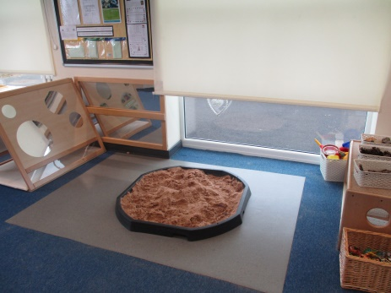
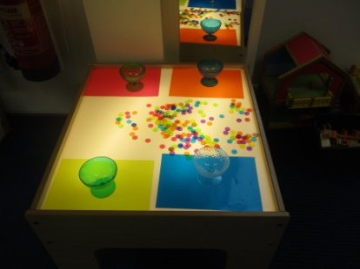
Early Years Foundation Stage (EYFS):
We follow the EYFS guidance and ensure children’s learning is planned through the following ways: in Prime Areas (children mostly develop these areas first) and Specific Areas (prime areas help children develop skills in specific areas).
Prime Areas = Personal, Social and Emotional Development
Physical Development
Communication and Language
Specific areas = Literacy
Mathematics
Understanding the World
Expressive Arts and Design

Characteristics of Effective Teaching and Learning (CoETL):
At Handale we allow children to develop by encouraging CoETL. They are:
- Playing and Exploring
- Active Learning
- Creating and thinking critically

Early Years:
Throughout Early Years we have rhymes, stories and counting on a daily basis. We develop all the skills needed as building blocks for a child’s development.
We develop phonics skills (basis for reading and writing). This begins in Pre-nursery and is developed throughout the session. In nursery this is developed in the session and in a short focused game daily. This is then developed in reception throughout the day and in a more formal phonics session daily.

Working with Parents/Carers:
Parents are a child’s first educator, at Handale we recognise this and we know the importance of working together. A child’s key person gives parents/carers a point of contact with the setting. They take note of children’s progress and will share this with parents/carers. At Handale we encourage an open door policy and therefore if you have any questions or would like more detail on any of the points on this handout please ask a member of the Early Years Team.
