
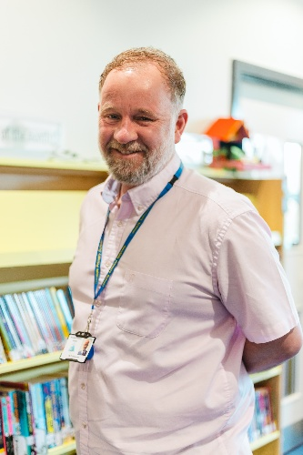
Handale Primary School
Safeguarding Children
Handale Primary School is committed to ensuring the well-being of every child and keeping them safe from emotional, mental and physical harm. Policies and procedures for safeguarding children and child protection can be accessed using:
www.handaleprimaryschool.co.uk or www.teescpp.org.uk/contact/redcar-cleveland
or via
Redcar and Cleveland Multi-Agency Children’s Hub (MACH)
Monday to Thursday 8:30am-5:00pm Friday 8:30am-4:30pm
Tel: 01642 130700
Email: RedcarMACH@redcar-cleveland.gov.uk
Out of hours: Emergency Duty Team- Tel: 01642 524552
In an emergency contact Cleveland Police by telephoning 101.
Alternatively, you may speak confidentially to a designated person in school.
The designated person with overall responsibility is
Mrs. Rio Farrier, Head Teacher.
If you have concerns about safety in and around Handale Primary School please contact
Mr. David Caley, Site Manager.
If you have concerns regarding the Head Teacher, please contact
Mr. Nick Blackburn, CEO.
Information can be found at www.lingfieldeducationtrust.com

Mrs. R Farrier
Head Teacher
Mr. P Emmerson
Deputy Head Teacher

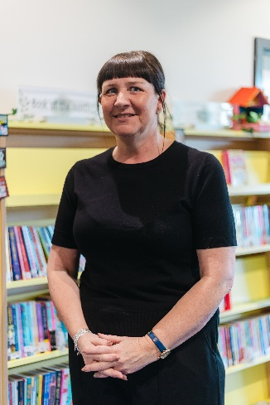


Mr. N Blackburn
Trust CEO

Miss. J Tully
Learning Mentor

Mr. D Fowler
Chair of Governors

