**HANDALE PRIMARY SCHOOL**

**SEND INFORMATION REPORT  
For Parents and Carers**



Creation Date:   
To be reviewed annually.

**Foreword**  
Special Educational Needs and / or a Disability (SEND) can affect many children throughout their school career and beyond. Whilst disabilities generally affect children long term, not all SEN difficulties should be seen as ‘Life Long’. SEND is seen by our school as the child requiring provision that is additional to, or different from the rest of the class. For example, they may have additional needs due to autism spectrum disorder, coordination problems, number understanding, significant sight problems – the list is endless and every child is unique. As such, a carefully planned approach is needed, often additional to high quality class teaching in order for these children to achieve as well as they can.

Our school and Trust has a variety of key policies which directly impact upon our provision for children with SEND, which are all available as part of our school and Trust websites, Some examples are:

* SEND and Inclusion Policy
* Admission Arrangements
* Accessibility Plan
* Equality Objectives

**Our Trust Mission and Guiding Principles**   
All schools within Lingfield Education Trust are bound by a common sense of duty and aspiration for all of our children. This is driven by our common mission – and what we want to be remembered for as a family of schools:

**Our SEND Mission…** *what do we want to be remembered for?*   
***The Trust had inclusion at its heart. It ensured that every child was seen, valued and included. All pupils thrived and went on to succeed in a fulfilling and meaningful life.***

In order to achieve our mission, we believe in the following principles in order to achieve our mission:

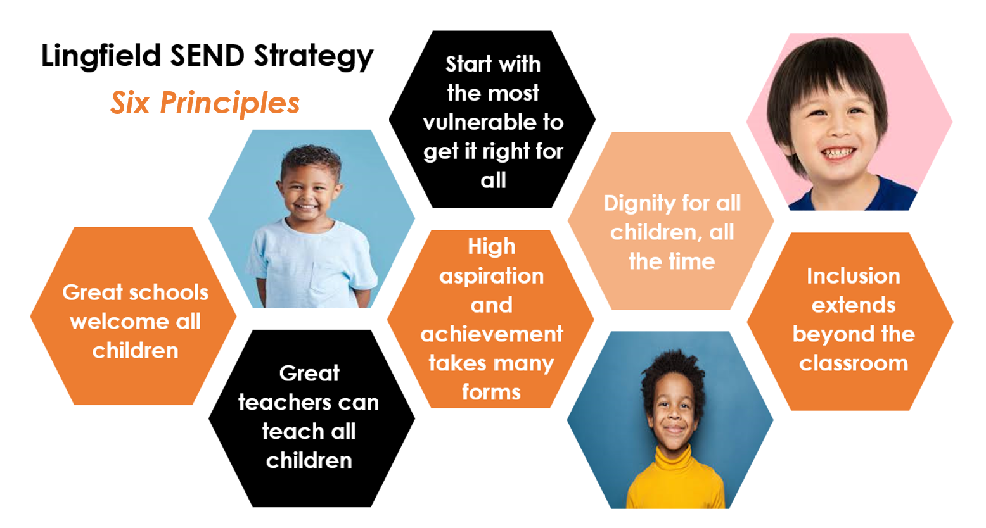

**Our Trust Charter**  
In line with our mission, the following parent charter guides our work with families each and every day. This charter forms part of our promise to you regarding what you can expect from us as a school, as parents and carers.

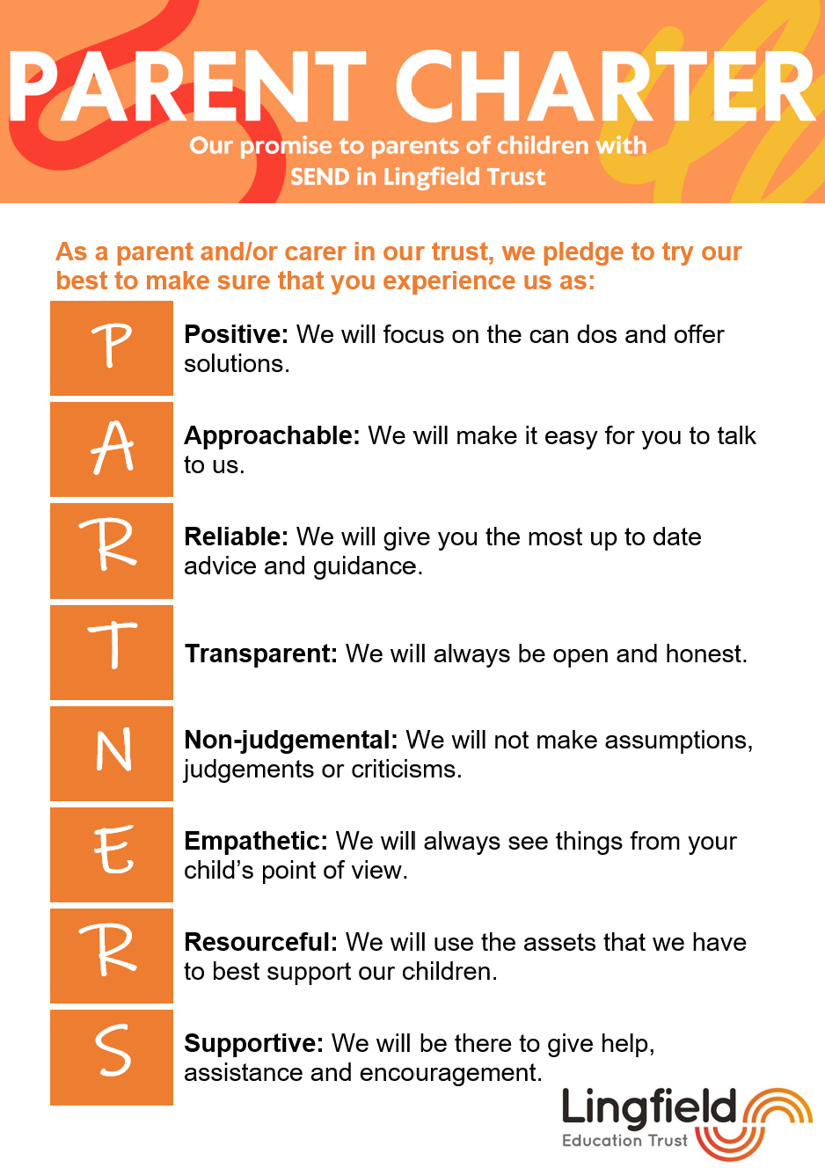

**What about..?**Below are some commonly asked questions about our school’s offer for children with an additional need. We hope that you find the information useful. If you do not find the information that you need, please get in touch!

**What is a ‘SENCO’, who is it and how do I contact them?**A SENDCO (Special Educational Needs and Disabilities Co-Ordinator) is a qualified teacher who has the responsibility for ensuring children with special educational needs or disabilities (SEND) receive the support they need in school. The SENDCO will work closely with teachers, parents and other professionals to identify children who require additional help and support in order for them to progress and succeed. The SENDCO will help put support plans in place, monitor progress and review strategies and support processes to ensure the needs of all children with SEND are being met appropriately.

The SENDCO at Handale Primary School is Mr Emmerson. You can contact them via the school email address – admin@handale.lingfieldtrust.org.uk or call the school office on 01642 640416.

Key contacts for SEND in our school are:

|  |  |
| --- | --- |
| **Head of School** | **Mrs Farrier** |
| **SENDCO** | **Mr Emmerson** |
| **SEND Governor** | **Mrs C Tyreman** |
| **Designated Safeguarding Lead** | **Mrs Farrier** |
| **Deputy Safeguarding Lead** | **Miss Tully and Mr Emmerson** |
| **Pastoral Lead** | **Miss Tully** |
| **Designated person for Looked After Children** | **Mr Williams** |

**Contact details:**Handale Primary School

West Park Avenue

Loftus

TS13 4RL

Tel: 01642 640416

Email: admin@handale.lingfieldtrust.org.uk

**What areas of SEN are provided for at our school?**

**How do we identify children who may have SEND and assess their needs?**Progress and development will be closely monitored by class teachers through ongoing observations and assessment. They will be looking for signs of difficulties within the different aspects of the child’s learning, behaviour, communication or physical needs. If concerns arise, teachers will highlight the child as a cause for concern, and this will be discussed with the SENDCO. The child will at that point be placed within a cause for concern category that runs separately to the SEND register.Parents will be informed of these discussions and encouraged to share their thoughts and concerns. The SENDCO will then decide whether any further movement through the SEND Code of Practice is necessary. If so, the child will be placed on the SEND register and a support plan will be devised to ensure the appropriate support is in place. If further advice is required, the SENDCO will liaise with other specialists to plan and implement further support.

**How do we consult with parents of children with SEN and involve them in their child’s education?**We aim to consult with parents about their child’s education through regular, open and supportive communication. Formal parent consultation evenings take place regularly throughout the school year. However, an additional parent consultation evening is provided at the beginning of each term to discuss their child’s support plan with them and discuss the child’s targets and the provision being put in place to ensure that they achieve these. Additionally, parents can make alternative appointments with their child’s class teacher or via the school office if required, at a time that is mutually convenient. School may also consult with parents via telephone calls, emails or Class Dojo. Parents are also frequently invited into school to share a range of activities and to informally discuss their child’s progress, which include enrichment afternoons, information sharing meetings, performances, school fayres and coffee mornings.

When discussing the needs of children with SEND, parents are encouraged to attend meetings and share their views around their child’s progress and development. SEND support plans are reviewed and updated regularly, and new targets are set. Copies of these plans are shared with parents for their information, and to allow them the opportunity to contribute their views. Parents of children with an Educational Health Care Plan (EHCP) are invited to annual review meetings where staff, parents and often other external professionals work together to review progress, discuss concerns and set new targets.

The SENDCO plays a key role in ensuring parents of children with SEND are informed and involved in decision-making, particularly when identifying needs or planning further support strategies. We believe parental involvement is an essential part of understanding the child’s needs and ensuring the correct support is effective and appropriate.

**How do we consult children with SEN and involve them in their education?**We actively involve children with SEND in their education by creating continuous opportunities for them to share their views, their wishes and feelings about their learning and support. This is done through regular discussions with familiar adults, using child-friendly visual aids and concrete resources, when needed, for children to share their preferences.

In all SEND support plans, children are given the opportunity to share their views on their education and support in place. Where appropriate, children are involved in their target setting and reviewing their own progress during SEND support meetings. By involving children with SEND in these discussions, we build confidence, promote independence and encourage ownership of their own progress and development.

**How do we assess and review children’s progress?**Regular reviews and assessments are an essential part of a child’s educational development. It ensures the support in place is effective and appropriate in meeting the child’s needs, and it allows teaching staff and the SENDCO to identify new or changing needs at an early stage.

To effectively assess the progress of children with SEND, we follow an Assess, Plan, Do, Review approach as described below:

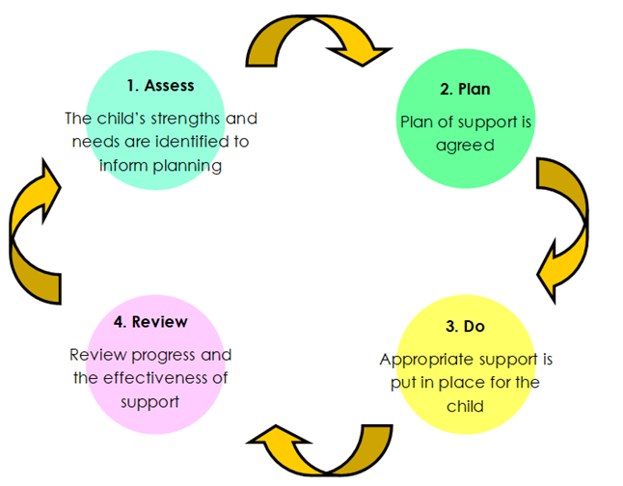

Assess - The child’s difficulties will be assessed to ensure the correct support is provided. Teachers, children and their parents will be involved in this stage of the process, giving them the opportunity to share their thoughts. This will be reviewed regularly.

Plan – School and parents and where appropriate, children will discuss the planning of support, and what it is we collectively want to achieve. All those involved will have a say in what support will be provided. A date will be set for when these outcomes will be reviewed and to see whether they have been achieved

Do – School will put the support from the planning stage in place. Support strategies will be shared with parents to encourage use at home, and to promote consistency for the child. The child’s teacher remains responsible for working with the child on a daily basis, and the SENDCO and other specialist staff will provide further advice if needed. They will also work closely with teachers to track progress and monitor the effectiveness of the support strategies in place.

Review – The planned support will be reviewed regularly, teaching staff and the SENDCO will evaluate the effectiveness of the support and adapt if necessary. Reviews will be completed at a minimum of three times a year.

This ongoing cycle ensures that the provision and support strategies in place are effective and focused on helping the child reach their full potential. The benefit of taking this approach also provides the opportunity to regularly review what is working well and importantly what can be improved from both a child and teacher perspective. Embedding a review cycle allows us to continuously support the needs of our SEND children, as well as continuously refresh the strategies that we apply.

**What additional support for learning is available to children with special educational needs?**In school we offer a range of additional support to ensure children with SEND are able to access learning and make a good level of progress. This support includes targeted interventions, differentiated teaching strategies, specialist resources, visual aids and assistive technology.

Alongside the support we offer in school, we work closely with a wide range of external agencies and specialists to seek advice, and to work collaboratively to plan and implement further support strategies. These services include:

• Speech and Language therapy

• Occupational therapy

• Educational Psychologist

• Outreach support

• STARS – Sensory Teaching Advisory Resource Service

• School nurse team

• CAMHS

• Social Care and Early Help

• The Bungalow Project – Counselling and children’s wellbeing service

• Attendance and Welfare service

Due to their expertise in their fields, these services can help school in supporting children with SEND by carrying out detailed assessments and providing recommendations for appropriate strategies and resources. By working collaboratively, we can ensure the most effective support is in place for our children with SEND.

**How do we support children moving between phases of education and in preparing for adulthood?**

In our school we support children with SEND through each phase of their education through a carefully planned approach. We collaborate with parents, previous or future settings and professionals to ensure smooth transitions between year groups and key stages. We use a range of strategies to support our pupils, such as additional visits to new classrooms, transition days including meet the teacher, visual supports such as timetables and now and next boards for understanding of new routines, social stories and transition booklets. These are all tailored to children’s individual needs and are implemented in time to prepare children for upcoming changes. Children with an EHCP are involved in the decision-making and target setting in line with the preparation for adulthood outcomes.

**What is our approach to teaching children with SEN?**The Lingfield Teaching Compass aims to embed a ‘SEND from the Start’ approach which ensures our fundamental offer provides a fully inclusive, broad and balanced curriculum for all children, including those with SEND. Teaching staff provide this through quality first teaching; a high standard of teaching that all children receive daily. This involves well-planned, engaging and accessible lessons that are adapted appropriately to meet the needs of all learners. This is implemented through a range of strategies such as visual aids, reduced language, use of prompts and particular seating arrangements. An accessible curriculum ensures all learners, regardless of their individual needs can participate in learning, make progress and feel included.

If a child with SEND is not making expected progress through quality first teaching, additional targeted support will be implemented focusing on specific areas of learning, such as reading, writing, maths, speech and communication or emotional regulation. Teachers and the SENDCO will work together to plan this additional support and to implement strategies or interventions to allow children with SEND to continue to access the curriculum.

**What adaptations are made to the curriculum and the learning environment of children with SEN?**Handale Primary School is a 2-storey building. The first floor is accessible by stairs or by a lift. There is a disabled parking on site and all visitors can access the main reception via an accessible entrance. All classrooms are wheelchair accessible and there is a disabled toilet on both floors with a changing room on the ground floor.

All classrooms aim to be ‘SEND friendly’ meaning many aspects of the environment are considered, such as the physical layout, visual support available around the room and sensory considerations such as lighting and noise levels. We have break out areas around school which provide a safe space for children with SEND to work in a calmer, quieter environment or to support their self-regulation. In addition to this, we offer a sensory room which provides a safe, calm and nurturing environment primarily for children who face difficulties in the mainstream classroom. This sensory room offers an alternative space for children, whether it be to provide a calm working space or to use for a movement or regulation break.

**How are equipment and facilities to support children special educational need secured?**We consider the needs of children with SEND and following the advice and recommendations shared through external services, we identify the required equipment and resources. These range from learning resources, sensory and physical support, emotional wellbeing tools, technological support and professional services. This is secured through school budget or the local authority’s high needs funding. School also carry out regular reviews to ensure facilities are appropriate and inclusive, making reasonable adjustments in line with the Equality Act 2010 to promote full access and involvement for all children with SEND.

**What expertise and training do staff have in order to support children with SEN?**All teachers have qualified teacher status and teaching assistants have a minimum of a Level 2 qualification. There is a programme of professional development to ensure teachers, teaching assistants and support staff meet the special educational needs of our children and stay up to date with current research into teaching, learning and safeguarding. The SENDCO holds the National award for Special Educational Needs and Disabilities qualification.

All staff are encouraged to enhance their skills and knowledge through ongoing continuous professional development. This includes training in areas such as autism, ADHD, dyslexia, sensory needs or targeted training such as the delivery of interventions, phonics programmes or occupational therapy strategies. The SENDCO directs class teachers to courses or training that are appropriate for particular children they are working with. Staff with expertise or a specialism share their knowledge and best practice amongst other staff to strengthen the quality of teaching and support across school.

**How is specialist expertise, such as educational psychology, secured?**If a child’s needs are not being met though Quality First Teaching and targeted in-school support, and there is evidence that more specialist support is required the SENDCO will seek further advice from external services. This usually follows the assess, plan, do, review approach, where school have identified concerns, implemented support and monitored progress over time. Following consultation with parents, the SENDCO will submit a referral to seek further support. This could include a speech and language therapist, occupational therapist or educational psychologist.

Handale Primary School works with a range of specialists regularly throughout the year, to provide regular support for children with SEND. Some of these include the speech and language service, the outreach and inclusion team and educational psychologist. The SENDCO co-ordinates these partnerships, arranges visits, assessments and termly reviews to ensure the advice and support shared is used effectively in school. Collaborative work between school and these services is essential in the planning and implementation of appropriate and effective support for children with SEND.

**How do we evaluate the effectiveness of our provision made for children with SEN?**To ensure support and strategies in place are meeting individual needs and enabling progress, SEND support plans and EHCPs are reviewed in line with national standards. This involves you as parents, teachers, specialists and the child where appropriate. Academic and personal development progress is monitored using assessments, observations and reports. We use provision mapping to review progress and attainment to identify which interventions and strategies have had the most impact. Pupil voice is gathered to understand your child’s views on their support and progress. The SENDCO and school leadership teams use this evidence to adapt and improve the provision to ensure it remains suitable and effective. Regular reviews with governors and Ofsted inspections form part of this evaluation process.

**How are children with SEN enabled to engage in activities with children in the school who do not have SEN, Including physical activities?**We believe all children including those with special educational needs should be offered a broad, balanced and inclusive curriculum. Children with SEND are supported to take part in all activities alongside their peers, including physical activities through the planning and implementation of reasonable adjustments. To enable this, a range of differentiated strategies will be considered, such as additional adult support, adaptive equipment and resources, simplifying instructions and vocabulary, adjusting tasks or using visual aids or assistive technology to suit specific needs. In order for these support strategies to be successful, teachers and the SENDCO carefully plan and introduce these to the children for them to participate safely and confidently. Where necessary, risk assessments and individual support plans will be used to ensure children can access activities and feel valued and included.

We invite all children including those with SEND to participate in our wide range of after school and lunchtime clubs, which are also differentiated and adapted to meet the individual needs of children as well as promote inclusivity. Our clubs offer opportunities to develop a range of academic and social skills as well as developing independence, communication, resilience and self-help skills.

**What support is available for improving emotional and social development?**   
Emotional and social skills are delivered through weekly PSHE lessons and mindful and wellbeing lunchtime and after school clubs. In addition to this, we offer a range of support to promote the development of emotional and social skills. Our pastoral lead, Miss Tully offers regular emotional support for children through one-to-one support or small group sessions. These include support with managing emotions, social difficulties, resilience and mental health. We also work closely with The Bungalow Project; a service which provides tailored mental health support to those who require it. The sensory room provides a safe space where children can spend time away from their classroom to self-regulate in a calm, quiet environment. When more specialist support is needed, school contact external specialist services such as CAMHS (Children and Adolescent Mental Health Service) and MIND. Essentially, we aim to build strong relationships and build a supportive culture, to promote safety and well-being.

**How do we support children who are looked after by the local authority and have SEN?**Each SEND child who is looked after through the local authority will have a personal education plan (PEP). This ensures children are offered support tailored to their individual needs. School work with the local authority, health and social care and carers to review the plan regularly. A designated teacher for looked after children works closely with the SENDCO to ensure the child’s needs have been identified and their needs are being met. We also work with carers, virtual schools and social workers to provide a consistent, nurturing learning environment with an aim to promote stability and inclusion.

**What are the arrangements for handling complaints from parents of children  
with SEN about the provision made at the school?**What are the arrangements for handling complaints from parents of children with SEND about the provision made at the school?

In the first instance, if you feel that our offer or approach hasn’t been quite right for your child, we will always encourage you to speak to us! We want to get it right, and work with you to do so. Often, our SENDCO is the best first port of call, but your child’s class teacher – or any leaders in school will be happy to meet with you to hear your concerns. Simply contact the school office to arrange an appointment. If after speaking with us you still have concerns, or wish to make a formal complaint, our Trust complaints policy can be found here:

<https://lingfieldeducationtrust.com/governance-policy/trust-policies/>

**What is the Local Authority ‘Local Offer’ and how do I find it?**

The Local Offer is information provided by the local authority that outlines the services and support available for children and young people aged 0-25 years with SEND and their families. It offers information, advice and guidance about the types of services and support available to you in your local area. The aim of the local offer is to help families understand what support is available in their area and how to access it.

You can find the local offer via the website at:

[**Redcar and Cleveland Information Directory | Redcar & Cleveland: Information Directory**](https://informationdirectory.redcar-cleveland.gov.uk/)

**Are their any support services for the parents of pupils with special educational needs?**There are several support services available for you as parents and carers. They offer free, confidential and impartial advice about the special educational need processes.

SENDIASS (Special Educational Needs and Disabilities Information Advice and Support Service). A free, impartial, and confidential service provided by Barnardos, offering information to young people with special educational needs and disabilities and to their parents and carers.

Parent carer forums – Local groups run by parents or carers of children with SEND who work together to improve services for families in the area. They share experiences, influence local decision making.

Local Authority services – Family support workers, early Help or SEND caseworkers who offer support through referrals, assessments and care plans.

Local Offer website – Every local authority offers a list of services available to parents, carers and their families offering advice and support.